CLASSIFICATION

WORKSHOP

September 2022

Compensation & Classification Unit
UCSB Human Resources

Human Resources Website
Job Builder

TABLE OF CONTENTS

I.Compensation & Classification Unit – Who are we? 3
  - What we do 4

II. Introduction to Writing Job Descriptions 5
  - Role of Job Descriptions 6
  - Guidelines for Writing a Job Description 7-8
  - Describing the Job 9-13
  - Writing Sentences for Job Descriptions 14
  - Job Description Wording Samples 15-18
III. Job Descriptions and Appointments: General Information 19
  - Where do JDs Live? 20
  - Updating a JD 21
  - Job Descriptions for Recruitment 22
  - Career and Partial-Year Career Appointments 23
  - Limited Appointments 24
  - Contract Appointments 25
  - Student Assistant/Casual Restricted Appointments 26
  - Non-UC Student Assistant Appointments 27
  - Volunteer Staff Appointments 28-29
IV. Classification: General Information 30
  - What is Classification and Why is it Important? 31
  - UCSB Classifications – Represented vs Policy Covered 32
  - BYA (By Agreement) Rate of Pay 33-34
  - Who Determines Classification? 35
  - Determinant Factors in Classifying Jobs 36-37
  - Common Misconceptions about Reclassifications 38
  - Classification Tools/Methods of Analysis 39
V. Classification Policies & Procedures 40
  - Preliminary Checklist for Reclasses 41
  - Requesting a Reclassification or Temporary Stipend 42
  - Reclass Process Flowchart 43
  - Reclass & Temp. Stipend Deadlines & Effective Dates 44
  - Salary Changes Upon Reclassification 45
  - Temporary Duty Assignments 46
  - Supervisory Designation 47
  - Confidentiality Designation 48
  - Employee Relations Code (ERC) 49-50
  - Background Checks 51

TABLE OF CONTENTS (CONT.)

VI. Compensation Policies & Procedures 52
  - Equity Increase Guidelines - PSS 53-54
  - Equity Increase Guidelines - MSP 55-56
  - In-Grade Salary Movement Guidelines - MSP 57-58
  - Merit Increases 59
  - Other Salary Increases 60
  - Performance Evaluations 61
  - FLSA and Overtime 62-64
  - Hours of Work 65-66
  - Shift and Weekend Differentials 67

VII. Appendix 68
  - Action Verbs 69-70
  - Glossary of Useful Verbs & Terms 71-76
  - Job Description Worksheets 77-79
  - Sample Series Concept / Sample Career Tracks Job Standard
    - Clerical/Administrative Assistant Series Concept 80-85
    - Financial Services CT Job Standard__________ 86-90
  - Career Tracks Supervisor Decision Tree 91
  - UCSB Career Tracks Salary Range Structure (PSS and MSP) 92
  - Student Employment Guidelines 93
WHO ARE WE?

COMPENSATION & CLASSIFICATION UNIT

Compensation is a broad area of Human Resources covering salary administration, classification of positions, application of overtime rules (FLSA), market surveys and other topics connected to employee remuneration. The role of the compensation analyst is to resolve salary and classification issues prior to the submission of formal classification requests. Therefore, departments are encouraged to develop close working relationships with the analyst assigned to their campus area (see assignments below). When the department is considering organizational changes that influence the distribution of job responsibilities in their units, consultation with the compensation analyst is strongly recommended. The analyst can advise the department on the potential impact of such changes on classification levels as well as the need to consult with Labor Relations, Talent Acquisition, etc., when appropriate.

Kathy Moore  Compensation Manager | - Chancellor’s Office, Human Resources, Arts & Lectures, Budget & Planning  - Wage Implementations
Linda Broen  Compensation Analyst | - Academic Affairs Division (Not including the Library, or Enterprise Technology Services)
Andrea Dittman  Compensation Analyst | - Division of Institutional Advancement  - Office of Research Division  - Enterprise Technology Services (ETS)  - Systemwide Education Abroad Program
Anna Fudge  Compensation Analyst | - Student Affairs Division  - Grad Division  - Division of Finance and Resource Management
John Ibach  Compensation Analyst | - Physical Facilities, Police, EH&S, & Library  - Auxiliary Services (UCEN, Faculty Club, etc)  - Housing & Residential Services  - VC Admin Services  - Athletics
Contact information can be found here: https://www.hr.ucsb.edu/contacts

Other areas of Human Resources include: Administration, Employee & Labor Relations, Employee Services, Talent Acquisition, Training & Development, and Workforce Administration

WHAT WE DO

• Conduct formal & informal job reviews

• Advise departments on how to write and revise job descriptions

• Assist with departmental organizational changes

• Advise campus regarding how classification decisions may impact the department

• Assist departments with the interpretation of Classification & Compensation policies and procedures. (i.e. FLSA, temporary assignments, merits, performance evaluations, equity, etc.)

• Conduct salary & classification studies

• Respond to/participate in market salary surveys

• Research and gather data in preparation for collective bargaining

• Assist with the design and development of compensation and classification programs

• Conduct individual and departmental salary equity studies

INTRODUCTION

TO WRITING

JOB DESCRIPTIONS

ROLE OF JOB DESCRIPTIONS

Job Content Evaluation

Establishing Career Paths/Succession Planning
Salary Survey Exchanges

Assigning Employees to Appropriate Jobs

Job Descriptions
Recruiting

Legal Defense
Organizational Design
Establishing Performance Standards

Every employee is REQUIRED to have a written and signed job description on file.
GUIDELINES FOR WRITING A JOB DESCRIPTION

1. Determine the major functions, which are the titles/groupings under which you include the duties. Select 3-6 major functions. Use only 1-5 words.

2. Determine the % of these functions in relation to the total job.

3. Put the major functions in order of importance, from greatest to least, NOT in % order.

4. For each function, determine the duties, which are actions taken when performing the job satisfactorily. It is an action that someone else can see, hear, or observe. Write no more than 6-8 duties. Answer the questions, what, how and why. Use simple, non-technical, but specific words.

5. Duties should be described as currently performed, and not in terms of future expectations. Think of your job as it is really done, not how it could be or should be done. Duty statements are easier to write if you start each one with an action verb such as ‘reconciles,’ ‘analyzes,’ ‘negotiates,’ ‘troubleshoots,’ etc.

6. Determine the frequency of each function (i.e. daily, weekly, monthly, etc.).

7. Determine the requirements of the position (skills, knowledge & abilities). Tie them directly to the duties (actions) to be performed in the job. A knowledge or skill is something you know or can do that helps you do the duties of your job well. Examples are:

• Public Speaking skill; including planning and preparing material and presenting it effectively
• Typing skills
• Speaking skills to talk with people of various educational and cultural backgrounds
• Skill in negotiation, including listening and persuading
• Clear, concise and precise writing of reports and letters
• Technical knowledge of systems

8. Determine if there are any physical, environmental or special demands.

9. When a job is performed by multiple FTE, incorporate the principal elements into a single generic job description and avoid specifying minor differences in the way the work might be performed.

10. Avoid repeating the organization/unit’s name in job description.

11. Avoid organizationally specific part numbers or form numbers.

12. Focus on essential activities. A duty that is performed frequently throughout the day may not be as “essential” or as critical to the job as something done only once or twice a week.

(continued)

GUIDELINES FOR WRITING A JOB DESCRIPTION (continued)

13. Disregard minor occasional duties that are common to all jobs or are normally taken for granted, unless they are still “essential” to the job. If nonessential, list under non-essential section of job description.

14. If you add a “Special Projects” function be sure to specify the on-going types of special projects that may come up and what duties would most likely be performed.

15. Consider adding a small extra function or duty statement to each job description such as “performs other duties as assigned” to cover the extra work that may fall on the position from time to time.

16. Avoid the narrative form. You are writing a job description, not a story. Remember that the length of a job description does not indicate the importance of the job. Ideally, the essential duties section of the job description should be no more than 1-2 pages.

DESCRIBING THE JOB

KNOWLEDGE, SKILLS AND ABILITIES (KSAs)
The KSAs describe the qualifications needed to fully perform the duties and responsibilities of a position. (Think of what would be the requirements for someone 6 months to a year into performing the work of a position.) KSAs are generally stronger requirements compared to the minimum requirements used for a recruitment; since minimum requirements are the qualifications needed to be hired into a position, not to fully perform the duties and responsibilities of a position.

Each Career Tracks job standard lists KSAs for each job level of the title. Departments can use the job standard KSAs as a starting point and then add in additional KSAs that are specific to their position in order to have a comprehensive list of KSAs for a job description.

DEGREE OF SUPERVISION
This section describes the way in which work is assigned, when it is reviewed, how it is reviewed, and what guidelines, prototypes and protocols are available.
Example -- Business Officer
Assignments are given in terms of broad organizational goals and objectives. Goal attainment is reviewed with department chairperson on a quarterly basis through presentation of status reports and formal discussions. Department, campus and governmental guidelines relative to budgetary control, contract and grant administration, and personnel management are available for reference; however, interpretation and original problem solving are required.

DEFINITIONS OF TYPES OF SUPERVISION RECEIVED:
Close Supervision- indicates that the incumbent is assigned duties according to specific procedures. Work is checked frequently and there may be formal training.

Supervision- indicates that the incumbent performs a variety of routine duties within established policies and procedures or by referral to the supervisor’s guidelines.

General Supervision- indicates that the incumbent develops procedures for performance of variety of duties; or performs complex duties within established policy guidelines.

Direction- indicates that the incumbent establishes procedures for attaining specific goals and objectives in a broad area of work. Only the final result of work completed is typically reviewed. Incumbent typically develops procedures within the limits of established policy guidelines.

General Direction- indicates that the incumbent receives guidance in terms of broad goals and overall objectives, and is responsible for establishing the methods to attain them. Generally, the incumbent is in charge of an area of work, and typically formulates policy for this area but does not necessarily have final authority for approving policy.

(continued)

DESCRIBING THE JOB (continued)

GENERAL SUMMARY OF DUTIES AND RESPONSIBILITIES:
A summary statement provides a synopsis of the major purpose of a position and its role in the department, and is required on every written job description.
Example -- Business Officer
Under direction of departmental chairperson, manages all business and support functions for the Department of Cybernetics. Major duties include supervision of nonacademic staff, materiel management, space utilization, preparation and management of departmental budget and fiscal control of contracts and grants.

FUNCTIONS:
1. A function is a major subdivision of work performed by one individual.

2. It includes similar duties that make up one area of responsibility.

3. Most jobs have 3-6 functions.

Examples:
Blank Assistant
A. Front Office Reception
B. Clerical Administrative Support
C. Meeting & Conference Coordination

Blank Assistant Supervisor
A. Supervision of Personnel
B. Program Support
C. Financial/Accounting Support
D. Special Projects
E. Other

Business Officer (Administrative Officer series*)
A. Budgetary Analysis
B. Budget & Financial Administration
C. Contract and grant Administration
D. Supervision of Personnel Resources
E. Space and Material Resource Management

*Business Officers are typically in the Administrative Officer series, but if the preponderance of the role is a better fit with another job function, classification may result in a different title.

(continued)

DESCRIBING THE JOB (continued)

DUTIES:
1. A duty is a work operation that is a logical, essential step in the performance of a function.

2. It defines the methods, procedures and techniques by which functions are carried out.

3. It should show:
What is done (action).
How it is done (procedures, materials, tools, or equipment).
Why it is done (purpose).

Examples:
Blank Assistant
Conference Coordination:
Schedules speakers for bi-monthly departmental seminars by calling individuals from established listings, ascertaining availability, determining event dates and composing confirming correspondence.

Blank Assistant Supervisor
Staffing:
Initiates personnel actions including selecting new employees, conducting performance evaluations, recommending salary increases, providing counseling on disciplinary problems and recommending corrective actions in order to maintain effective staffing and production levels.

Business Officer
Budgetary Analysis:
Plans and prepares the annual budget by integrating departmental goals and program plans; research, laboratory and administrative requirements; and faculty, student and other statistical data.

4. Begin each duty statement with a present tense action verb, e.g., writes, calibrates, analyzes.

5. Carefully clarify the following verbs that have a variety of meanings and connotations:

- Analyzes
- Acts as liaison
- Prepares
- Supervises
- Handles
- Edits
- Manages

- DESCRIBING THE JOB (continued)

Examples of Clarification:

Manuscript Production
Edits manuscripts for researchers by correcting spelling, faulty phrasing and imperfect punctuation.
OR
Edits manuscript for researchers with authority to review critically from a subject matter standpoint, checking and verifying content, condensing over elaborated topics, making additions to topics inadequately covered and rearranging material when not effectively presented.

Preparing Reports
Prepares statistical tables by seeking out sources of basic information, planning the schedule and means of collecting the information, designing tables and writing interpretive text.
OR
Prepares statistical tables by copying data from given sections of a schedule, posting the data to a given column and line on a tabulation sheet, adding the columns, and computing the averages and percentages within Excel.

6. You can use the following alternative duty statement format when there is too much information for a single sentence (being mindful of the overall length of the job description).

Example
Processes annual staff merit increases:
- Answers questions regarding staff merit increase policy.
- Monitors increases for budgetary restrictions and negotiates needed exceptions with the Dean’s Office.

7. Define uncommon abbreviations.

8. Do not include references to personal qualities or skills.

9. Provide supporting data to substantiate qualitative terms, e.g., complex, large.

10. Avoid phrases such as “assists in,” “responsible for,” and “involved with” which obscure the action.

Example
(Poor) Assists Admin. Asst. in budget management by monitoring 30 accounts.

(Good) Monitors 30 intramural and extramural supply and expense accounts by posting expenditures and reconciling balances against the General Ledger.
DESCRIBING THE JOB (continued)

EXPLANATION OF AMERICANS WITH DISABILITIES ACT 1990 (ADA) REQUIREMENTS

ESSENTIAL DUTIES:

The Americans with Disabilities Act 1990 (ADA) requires employers to consider the essential duties of a job in evaluations and assessing applicant qualifications. An essential duty is any task which is a basic, necessary and integral part of the job. In addition, when considering essentiality, one must focus upon whether the duty is essential to this particular job and not to the department as a whole. Further distinctions between essential vs. non-essential duties are the following:

- Are the duties required to be performed on a regular basis? If the duties are rarely performed, they may not be essential.
- Is the duty highly specialized? The need for special expertise is an indication of an essential duty.

NON-ESSENTIAL DUTIES:

Duties that are peripheral, incidental or are a minimal part of the job are considered non-essential.
Further points to consider:

- Would removing the duty fundamentally change the job? If not, the duty is non-essential.
B. Are there other employees available to perform the duty? If it is feasible to redistribute the work, the duty may be non-essential.

A statement such as “Other: May perform other duties as assigned” should be labeled as NON-ESSENTIAL unless specific duties and/or tasks are given to define what the “other” duties are.

Note: It is the supervisor’s responsibility to completely and accurately fill out the ADA section of the job description.

WRITING SENTENCES FOR JOB DESCRIPTIONS

- Use clear and concise language.
  - When possible, use words that have a single meaning.
  - Use examples/explanations for words that have varying interpretations.

- Use non-technical language whenever possible. A good job description explains the objectives, duties, and responsibilities of a job in a manner that is understandable to a layperson.

- Use telegraphic sentence style (implied subject/verb/object/explanatory phrase).
  - Avoid unnecessary words.
Example:
The job incumbent transports all company mail to various locations throughout the entire facility.

- Keep sentence structure as simple as possible; omit all words that do not contribute necessary information.

- Begin each sentence with an active verb; always use the present tense.

- Whenever possible, describe the desired outcome of the work, rather than the method for accomplishing that outcome. For example, instead of “writes down phone messages”- a task-oriented approach, you might say, “accurately records phone messages.”

- Avoid words that are not specific to what the employee does. Words to avoid include “handles,” “checks,” “prepares,” “examines,” and “sends.” If these words are the most accurate and specific available, it may be acceptable to use them; if a more specific term describes the task more clearly, use it.

- Use generic terms instead of proprietary names (“Microsoft,” “Xerox,” “Mac,” etc.).

- Avoid gender-based language.

- Qualify whenever possible. State “files alphabetically” instead of just “files.”

JOB DESCRIPTION WORDING SAMPLES

Poorly Written Duty Statement | New and Improved Duty Statement(s)
Maintains the departmental web site. | Web Page Development  -Consults with department managers and technical staff in determining web page content and layout.  -Creates web pages using HTML and graphics editors to produce web pages that meet the needs of the department.  -Creates and maintains web page templates and guidelines.  -Trains department web managers in web page development using various training tools, giving them a basic understanding of HTML and web page design.  -Assists department web managers by answering design and coding questions so departments can develop and maintain their own web pages.  Web Page Maintenance  -Reviews department’s web pages to ensure that they meet department guidelines.  -Maintains web pages by reviewing their content and links and editing them as appropriate to ensure web pages are timely and accurate.  Network and Software Maintenance  -Manages web server security for users and virtual web servers to ensure the proper access and availability of the web server.  -Repairs net stations by troubleshooting and performing minor repairs to hardware and system software setup ensuring the availability of net stations to students.  -Evaluates web development tool software by researching, loading, and testing the software.

JOB DESCRIPTION WORDING SAMPLES (cont)

Poorly Written Duty Statement | New and Improved Duty Statement(s)
The incumbent will handle all aspects of the department budget by herself. | Monitors and controls all expenditures across multiple fund sources; reviews records of day-to-day expenses and income on multiple spreadsheets. Accesses multiple accounting databases to reconcile and verify the ledgers for accuracy of transactions.  Responsible for providing financial coordination through controlling, reviewing, reconciling, reporting and evaluating the fiscal operations  Reviews all paperwork for financial transactions, reviews expenditures, reconciles General Ledger accounts, and prepares cost projections and monthly financial reports using self-designed computerized accounting systems, databases, and spreadsheets.

He/she gets the mail from mailroom, sorts it by name, and opens the ones for the boss – the rest go in the in-boxes. | Sorts and delivers US and Campus mail incoming; picks up outgoing mail for processing. Distributes daily mail, University ID cards, and payroll and miscellaneous checks, adhering to audit policies. Coordinates mail distribution for faculty on leave and individuals who have left the university. Delivers or retrieves materials to various campus offices.

JOB DESCRIPTION WORDING SAMPLES (cont)

Poorly Written Duty Statement | New and Improved Duty Statement(s)
The Student Advisor will meet with students frequently and helps them figure out which classes to take, and other related matters. | Serves as daily advisor to undergraduate students on all matters concerning their academic welfare, referring students as appropriate. Communicates effectively with students, faculty, and staff in administrative units.  Advises and assists in development of individualized study programs. Develops, prepares, organizes, and monitors student information systems and student files; integrates departmental and STAR data. Apprises students of department and university programs, degree requirements, and course schedules. Disseminates petitions to students. Evaluates student needs and exercises independent judgment in referring students for further assistance to department faculty advisors or university offices, such as the College of Letters and Science, Office of Admissions, Office of the Registrar, Financial Aid, EOP, Counseling and Career Services, and the Ombud's Office.

JOB DESCRIPTION WORDING SAMPLES (cont)

Poorly Written Duty Statement | New and Improved Duty Statement(s)
Performs the highest level of clerical assistance to the Chair including handling sensitive matters where professionalism and confidentiality are a must. | Answers and screens incoming telephone calls and forwards to appropriate staff personnel. Interacts with clients, customers, staff and potential visitors via email, telephone, and FAX. Screens appointments and phone calls for Chair and staff according to relevance and urgency, exercising independent judgment.  Independently composes memos for Chair and Associate Chair. Arranges regular and occasional meetings. Analyzes and filters all Chairs’ office communications and is conversant and knowledgeable on issues and activities of the Chair and Department in order to respond on the Chair's behalf as and when necessary. Determines appropriate courses of action in response to requests relating to the Chair.  Provides daily, direct administrative support to the Chair. Full responsibility for developing and maintaining comprehensive computer record-keeping and word processing systems. Prepares reports, compiles, drafts and edits memos, correspondence, databases, and historical data. Has independent decision-making authority in multiple administrative areas.  Coordinates communications with administrators, faculty, and staff in academic departments, other administrative offices, the Chancellors Office, locally and internationally. Maintains and ensures complete accuracy for complex schedule of the Chair and for the office as a whole. Responsible for managing master calendar and overseeing the scheduling of all appointments.

JOB DESCRIPTIONS

AND

APPOINTMENTS:

General Information

WHERE DO JOB DESCRIPTIONS LIVE?

The Job Builder online system stores the most current and historical job descriptions in an electronic JD library. Because the JD library does not allow for original signatures, we require that each department print off the JD from the JD library, obtain the appropriate signatures, and store the JD in their departmental personnel files. Here is a list of the various kinds of job descriptions and where the originals are stored:

JD Type | House of Record
Career and Limited Appointment (JDs):  (Current and Historical) | Electronic Copy: Job Builder  (JDs created after the implementation of Job Builder)  Hard Copy with Signatures: Departmental personnel files  (JDs created prior to the implementation of Job Builder)
Casual/Restricted JDs:  (Student Assistants) | Electronic Copy (Template): Department  Hard Copy with Signatures: Departmental personnel files
Contract JDs and Contracts | Electronic Copy of JD: Job Builder  Submit electronic Copy of JD and Contract via DocuSign Contract with electronic signatures: Human Resources electronic files.

UPDATING A JOB DESCRIPTION

Should job descriptions be updated every time a change occurs?

Not necessarily. We ask that Managers and Supervisors electronically submit updated job descriptions to Compensation (via Job Builder) when significant changes occur that might affect the overall distribution of work or reporting relationship. For instance, there might be a 20% function listed on the job description that becomes obsolete after a few years. Did that 20% time get absorbed in the other duties on the job description or did it get replaced by a new function or duty? A situation such as this would be cause for submitting an updated job description.

Examples of when not to submit an updated job description would be when an incumbent’s salary rate changes, when there are changes in the non-essential duties of the position, or when there are infrequent or random duties being assigned by management. The job description is meant to be a close estimate of the work assigned to an employee and depending on business necessity, Managers and Supervisors may have the need to occasionally assign duties to employees that are not specified in the job description. If the duties become a regular part of their job, however, then an updated job description would be warranted. Certain temporary assignments may fit the criteria for a temporary stipend. Please refer to the procedures for Temporary Duty Assignments.

Process:

To submit a job description update, the department uses the “Revise Job Description” quick link in Job Builder, selects the job description they wish to work on. The department begins the workflow, makes all needed updates to the job description and provides notes regarding what has prompted the changes. The department submits the update to Compensation once the appropriate approvals have been obtained. Compensation will then review and approve the JD, after which it can be found in the Job Builder Job Library, and Job Catalog. A JD acknowledgement will be emailed to the employee if there is an incumbent in the position. This acknowledgement replaces the past process of printing out hard copies of the job description, obtaining wet signatures, and keeping a signed hard copy of the JD in the incumbent’s personnel file.

JOB DESCRIPTIONS FOR RECRUITMENT

If a department chooses to recruit for a vacant position and there are no changes to the job description, it is quick and easy to begin the recruitment process. The hiring department simply goes into the TAM module of UCPath and creates a Job Opening. The previous incumbent’s JD is used as the basis for the Job Opening process. (Note: this process assumes that the previous employee’s JD was already input into Job Builder.)

If a department chooses to update or reclassify a vacant position prior to the start of recruitment, they should follow the normal procedures for either updating or reclassifying a JD. Be sure to select “Yes” for the question “Is this for the purposes of a recruitment?” which is located on the “Action Justification” tab – this will alert the compensation analyst to the urgency of the review. Once the hiring department has submitted their update or reclass request within Job Builder, the compensation analyst for their area will make it a priority and will review the job description. After the JD has been approved, it will be available in Job Builder and the hiring department can download a copy to be used when they are ready to create a job opening in the TAM module of UCPath.

How to Avoid Delays in Conducting a Recruitment:

Recruitment JDs that require classification review are given first priority to meet advertising deadlines in Talent Acquisition. Issues that might lengthen the review process and delay the start of the requisition process are:

- Newly created positions (as distinguished from vacant positions)
- Positions with significant changes in job duties or added/deleted supervision
- Positions noted by Compensation as needing additional review to ensure campus equity in the use of classification titles
- Job descriptions that are not clearly written or don’t reflect the nature of the work performed.

It is advisable that you contact your compensation analyst prior to inputting a JD action into Job Builder that may involve one of the four factors cited above. This step will expedite the process.

CAREER APPOINTMENTS

Career Appointments are appointments established at a fixed or variable percentage of time, at 50% or more of full-time, which are expected to continue for one year or longer.
Each Career appointment MUST have a job description. All Career appointment job descriptions require classification review and approval by HR Compensation.
A competitive recruitment is required for Career appointments.
Once the JD has been approved, and is in Job Builder, and an incumbent is hired, the incumbent will be sent a JD acknowledgement email. This acknowledgement process replaces the need for the department to obtain wet signatures on a hard copy of the JD and to then keep a copy of the signed JD in the employee’s personnel file.

PARTIAL-YEAR CARER APPOINTMENTS

Partial-year Career appointments are established at a fixed or variable percentage of time at 50 percent or more of full-time, which is expected to continue for one year or longer, and with regularly scheduled furlough periods. Furlough periods cannot exceed three months per calendar year, and should be scheduled per local procedures. Partial-year career appointments are used to accommodate foreseeable seasonal fluctuations in staffing, budgetary, operational, or other University needs.

During a regularly scheduled furlough period the appointee remains an employee with the University but is not currently working in the partial-year career appointment. Time on furlough is not considered time on pay status. An appointee cannot use vacation leave, sick leave, paid time off (PTO) or compensatory time off (CTO) when not on pay status.

Each Partial-Year Career appointment MUST have an approved job description.. All Partial-Year Career appointment job descriptions require classification review and approval by HR.

A competitive recruitment is required for Partial-Year Career appointments.

Once the JD has been approved, and is in Job Builder, and an incumbent is hired, the incumbent will be sent a JD acknowledgement email. This acknowledgement process replaces the need for the department to obtain wet signatures on a hard copy of the JD and to then keep a copy of the signed JD in the employee’s personnel file.

LIMITED APPOINTMENTS

Limited Appointments may be established at any percentage of time during which the appointee is expected to be on pay status for less than 1,000 hours in a period of 12 consecutive months. Limited appointments are typically of short duration.
Limited appointment job descriptions require classification review and approval by HR.
Once the JD has been approved, is in Job Builder, and an incumbent has been hired, the incumbent will be sent a JD acknowledgement email from Job Builder. This JD acknowledgement process replaces the need for the department to obtain wet signatures on a hard copy of the JD and to then keep a copy of the signed JD in the employee’s personnel file.

CONTRACT APPOINTMENTS

The terms and conditions of employment between the University and an employee in a contract position are specified in a written employment contract. These appointments have a fixed or variable percentage of time and may only be established under the following conditions:

The position is in a non-represented title in either the Professional and Support Staff (PSS) (Tier 1) program or Managers and Senior Professionals (MSP) (Tier 2) program;

AND

- The position has special salary requirements or unique occupational terms and conditions of employment which, by industry standards, is typically covered by an employment contract (e.g. Industry Standard Contract). These positions are exempt from the limit on contract duration and will be designated as such by the Director of Human Resources in consultation with the Affirmative Action Officer. Examples of these are fundraisers and coaches. Although these contracts may be renewed annually, the positions are expected to be of indefinite duration.

OR

- The position is normally associated with projects that have a specific end date (e.g. Term Contract). Examples of when a Term Contract might be appropriate are:

- Projects with specific objectives and defined outcomes;
- Positions with special salary requirements;
- Positions where funding may be short-term; or
- CONTRACT APPOINTMENTS (cont)

- Departments with a temporary need during restructuring, reorganization, or workflow redesign efforts.

The duration of a term contract can be up to four years and may be extended for up to one additional year for a maximum total of five years. Re-appointment in a term contract position beyond that date is not permitted.

A competitive recruitment is required FOR ALL CONTRACT APPOINTMENTS unless a waiver of recruitment is approved by Human Resources.

Contract templates are available on the Human Resources web site under the Forms section at http://hr.ucsb.edu Please contact the Contract Administrator in HR Talent Acquisition if you need to modify a contract template.

To hire an employee on contract, the department must first submit the proposed job description to Compensation via Job Builder. Once the job description is approved, the department then submits the approved job description, and the employment contract via Docusign, or via a ServiceNow ticket to the Contract Administrator in HR Talent Acquisition.

Once the classification level of the position has been determined by the Compensation unit, the salary for the entire term of the contract is negotiated by the department head and the employee before the appointment commences. The salary amount must fall within the salary range for the assigned classification. Conditions for variable compensation can be stipulated in the contract. When the contract terminates or is amended through re-negotiation during its current term, the salary and other provisions can be altered.

Conversion from Contract to Career Appointment: If a contract position was openly recruited (through the HR Talent Acquisition) at the onset of the appointment, then the conversion can be made without further recruitment. The Talent Acquisition unit in Human Resources must be consulted in situations like this and an update to the job description, via Job Builder, would be necessary to reflect the change in appointment type.

Reclassifying a Contract: (NEW) If a department wishes to make significant changes to the duties of a contract position that warrant a different classification, they must submit a reclass proposal via Job Builder to have the JD reviewed and approved. Upon approval of the JD, the department must request changes to the position in UCPath and then submit a ServiceNow ticket to have the employment contract reviewed (HR ServiceNow portal > Human Resources >Talent Acquisition Services). Attach the approved job description and the completed and signed employment contract to the ServiceNow ticket.
STUDENT ASSISTANT / CASUAL RESTRICTED APPOINTMENTS

Student Assistant positions are classified and administered by the hiring department. Job descriptions are required for each student employee, though are not created or stored in Job Builder, and signed copies should be housed in the hiring department:

Student Assistant 1 (4922) (Non-Exempt, Hourly, Casual Restricted) $15.00 - $40.00/hr
Under supervision, Student Assistant 1s perform duties ranging from unskilled to skilled and/or specialized in a variety of positions that typically require the use of manual, clerical, advising, public contact, and/or analytical skills, and perform other related duties as required. The series is characterized by the generally temporary nature of appointments, the general absence of continuing responsibility for the work performed, and the diversity of duties that may be assigned. The appointment type for Student Assistant 1 positions is Casual/Restricted.

Student Activities Appointed Official (4329) (Non-Exempt, BYA: flat rate or hourly, Casual Restricted)
Another type of student assistant position is the Student Activities Appointed Official. This is a title that can only be used for registered UC students and has a BYA salary plan. For instructions on how to administer a BYA appointment, please refer to the BYA appointment section in this book.

Student Activities Appointed Officials exercise administrative authority in carrying out the duties of the positions for which they are selected. They are accountable to the appointing authority for the successful operation of the function assigned. Assignments may be short term or intermittent in nature or operational for the academic years.
Examples of responsibilities are as follows:
- --The Chairperson of the Programming Board develops organizational structure, coordinates the work of the various program directors in programming, scheduling, planning, and publicity and keeps administrative office hours for a specified number of hours per week during the academic year.

- --The Director of Activities Fairs organizes, schedules, promotes, and makes all arrangements for designated special events, serving as liaison with outside groups or individuals and coordinating activities with campus services and other events directors.

- --The Pep Band Director selects band personnel, orders supplies, schedules practice sessions, and makes transportation and all other arrangements for musical performances.

- --The Director of Welcome Week plans and coordinates games, rallies, and other activities, supervising events and making arrangements for space, tickets, refreshments and cleanup.

- --The Promotion Artist is responsible for design, drafting, layout, typesetting and distribution of posters, brochures and other publicity materials.

NON-UC STUDENT ASSISTANT APPOINTMENTS
Non- UC Student Assistant 1 (4927) (Non-Exempt, Hourly, Limited) $15.00 - $40.00/hr

This series can be used to temporarily fill student positions with non-UC students. This is a temporary solution and should only be used for a one-quarter duration to fill student positions. Departments must request HR approval in advance of such hires. The Non-UC Student Assistant series title (4927) has the same pay structure as the Student Assistant title:

These titles have a Limited appointment type (not “Casual Restricted”). The following are examples of uses of the Non-UC Student Assistant title:

Examples of Appropriate Uses:
- 1st Priority: Student from a non-UC college or university here for one quarter only.
- 2nd Priority: High school student working for one quarter.
- Student from a special needs school, such as, PathPoint, UCP Inc. etc.

Examples of Inappropriate Uses:
- Non-student community member hired due to unavailability of UCSB students
- Non-student married to a UCSB student and living/working in UCSB off-campus housing
- UC Extension Student, Adult Ed Student, etc.

NOTE: Students taking one quarter off or staying on for one quarter after graduation may remain in their existing student assistant appointment for a maximum of one quarter as a casual restricted employee.

Job Descriptions: Signed job descriptions are required for ALL Non-UC Student Assistant positions and are created by the department outside of Job Builder. The department must submit a request via Service Now, to HR Compensation for review and approval of any Non-UC Student prior to any hire. On the request the department indicates the reason for needing to hire a Non-UC Student Assistant, and includes information on where they are a registered student.

Appointment Information: All Non-UC Student Assistants will be hired as limited appointments, not to attain 1000 hours in any rolling 12 months. These positions are not meant to be career. These are non-exempt, hourly positions and therefore FLSA (overtime) rules apply. Be sure and calculate premium overtime if the employee works over 40 hours in a work week. If the employee works 50% or more in a given calendar month, then they are eligible to earn sick leave and holiday pay (if there are any holidays in the month).

Please note that in longer term cases of being unable to find UC students to fill student positions, it is very important to have the work classified into the appropriate non-student title or bargaining unit title when the work is identified as such (i.e. Food Service Workers, Clerical, Custodians, etc.). We have a legal obligation to pay negotiated bargaining unit wages for these positions when no students are available to fill them, even if that means having a student and a non-student working side-by-side earning different wages for similar work.
VOLUNTEER STAFF APPOINTMENTS

Introduction and Purpose
Volunteer staff appointments (without salary) are to be utilized whenever an individual volunteers their assistance or services to the University and receives no compensation. Individuals who volunteer their time and expertise to the University provide an important service to the University and help further its mission of teaching, research and public service. In turn, volunteers gain valuable experiences and a sense of personal satisfaction.

These guidelines are intended to help promote a productive, safe and mutually beneficial environment for volunteers and for the campus by setting appropriate expectations and clarifying roles and responsibilities for both volunteers and their sponsoring department or unit.

APPLICABILITY
Federal regulations (29 CFR § 553.101-106) define a volunteer as an individual who:

1. Performs hours of service for a public employer for civic, charitable or humanitarian reasons;
2. Provides the services without any expectation of compensation;
3. Offers services freely and without pressure or coercion from the employer; and
4. Does not perform the same type of services as an employee of the same public employer.

For the purpose of workers’ compensation coverage, a volunteer is further defined as a person rendering services to the University where:

1. The University has control and direct supervisory responsibility over the manner and result of the services rendered; and
2. The volunteer receives no remuneration for such services other than meals, transportation, lodging, or reimbursement for incidental expenses, if appropriate.

The following categories do NOT fall within the volunteer definition:
1. The service provided is solely in pursuit of the individual’s personal education goals;
2. The individual receives remuneration for services rendered from a non-UC payroll, e.g., visitors or guests on per diem or travel allowance or academic or research visitors receiving support from home institutions.
3. The individual is sponsored by an outside agency and provides service to the University through that sponsoring agency, e.g., Red Cross volunteers or United Way volunteers;
4. The individual is an off-campus volunteer who is sponsored or referred by the University but is not under the direct supervision and control of the University, e.g., Student Internships, Student Teachers, etc.
5. Guests of the University such as: casual visitors, computer users who are employees of an organization which has a formal contractual agreement to use computer facilities; or retired employees who desire occasional access to campus/laboratory/recreational facilities.
VOLUNTEER STAFF APPOINTMENTS (cont)

Procedures:
1. Complete the Workers’ Compensation Program Volunteer Registration Form and send a copy to Workers’ Compensation, Business Services. For further information and a modifiable PDF form, go to: https://www.ehs.ucsb.edu/riskmanagement/volunteers
2. Departments may also need to complete the UC Waiver of Liability - Elective/Voluntary Activities, depending on the nature of the duties. For further information and a modifiable PDF form, go to: https://www.ehs.ucsb.edu/riskmanagement/waiver-liability or contact Risk Management at x2860.
3. Certain volunteers who perform sensitive tasks, such as the care and security of children or the handling of cash, are required to submit to, and satisfactorily complete, a criminal background check. For more information, visit: https://www.hr.ucsb.edu/index.php/hr-units/talent-acquisition/all-about-background-checks
4. Volunteers are not required to be entered into the Payroll/Personnel System and to sign the University of California Loyalty Oath; however, they may be required to sign the University’s patent acknowledgment form if they use University research facilities.
5. In the case of minors who have not graduated from high school, a work permit must be obtained prior to the beginning date of their service. Minors must not enter into a work situation without an approved work permit. For more information, visit: https://www.hr.ucsb.edu/hr-units/talent-acquisition/employment

CLASSIFICATION:

General Information

WHAT IS CLASSIFICATION AND WHY IS IT IMPORTANT?

Classification is a means of
identifying the value of a job
in relation to other jobs
in an organization and in the market

GOAL

To pay people fairly and equitably

UCSB CLASSIFICATIONS: REPRESENTED vs POLICY COVERED
Represented Titles  CBU’s (Collective Bargaining Units): |  | Policy Covered (Non-Represented) Titles - 99’s
CX (TEAMSTERS 2010 – Clerical)  Blank Assistants, Library Assistants, Child Development Center Teacher |  | TIER I
SX (AFSCME - Service)  Building Maintenance Worker, Cook, Custodian, Groundskeeper, Laborer, Parking Rep, Auto Equip Oper, Auto Tech. |  | PSS (Professional & Support Staff) –  Support Staff (Grades 15-17)  Blank Asst 2/Sup, Blank Asst, Library Asst,  Sr. Storekeeper/Sup.
DX (UAPD)
Physicians and Dentists
EX/PCT (AFSCME-Patient Care Tech)  Blank Hospital Asst, Lic Voc Nurse, Dental Asst, Dental Hygienist, Pharmacy Asst, Radiologic Tech. |  | PSS (Professional & Support Staff) –  Professional Staff (Grades 18-24)  Financial Services Analyst, Student Services Advisor, Data Systems Analyst, Information Systems Analyst.
HX (UPTE - Healthcare)
Pharmacist, Clinical Lab Tech., Counseling Psychologist
NX (CNA - Registered Nurses)  Nurse Practitioner, Clinical Nurse. |  | TIER II
RX (UPTE - Research)  Staff Research Associate, Museum Scientist. |  | MSP (Mgrs & Senior Professionals) -- Grades 21-30  Communications Manager, EH&S Manager, Accounting Manager, Facilities Manager, Employment Manager.
TX (UPTE - Technical)  Computer Res Specialist, Editor, Writer, Artist, Lab Asst, Dev Tech, EH&S Tech, Elec Tech., Producer-Director, Business Technical Support Analyst. |  | SMG (Sr Mgmt Group) -- Grades A-E  Chancellor, Vice Chancellor.
K8 (Teamsters Local 2010 - Skilled Trades)  Carpenter, Electrician, HVAC Mech, Painter, Plumber, Locksmith. |  | SMG (Sr Mgmt Group) -- Grades A-E  Chancellor, Vice Chancellor.  Policies:  Tier 1 and 2 employees are governed by PPSM & UCSB Local Policies and procedures.
PA (Police Unit)
Police Officers only.

Contracts:
Each CBU is governed by a unique collective bargaining agreement.
NOTE: For a complete list of classifications used at UCSB, refer to the Title Code System (TCS) .
BYA (BY AGREEMENT) RATE OF PAY

What is a “BYA”? BYA stands for “By Agreement.” By agreement, for the purposes of non-academic, non-represented staff positions at UCSB, refers to the agreed upon rate of pay for a body of work that has unusual or unique pay circumstances (as determined by the Compensation Unit) making it difficult to pay according to normal pay and classification standards. For example, someone may be hired to perform work on-site at the university for one hour yet they spent a significant amount of preparation time prior to arriving. A “by agreement” position allows you to fully compensate that person with a flat amount for the time they may have spent rehearsing, researching, planning, designing and creating, in preparation for their one hour of time spent at the university. BYA positions are primarily limited appointments.

Some BYA positions have pay circumstances similar to that of an hourly worker. In these instances, flat rate compensation is determined by calculating an agreed upon hourly wage multiplied by total hours worked per month (including appropriate overtime pay if hours exceed 40 in a workweek).

What kinds of positions are coded as BYA? A few title codes are officially coded as BYA. Only the following titles can be BYA:
-- Rec Program Instructor (various title codes) -- (exempt & non-exempt)
-- Resident Advisor (4570) (live-in only) -- (non-exempt)
-- Athletics Processionals (various title codes) – (exempt & non-exempt)
-- Coaches (various title codes) -- (exempt & non-exempt)
-- Performing Artist (various title codes) – (exempt)
-- Massage Therapist (9461) – (non-exempt)
-- Admissions Evaluator (4511) – (exempt)
-- Unclassified (9999) “Special Presenter/Speaker” -- (exempt)
-- Appointed Official, Student Activities (4329) – (non-exempt)
-- Student Notetakers (9920) – (non-exempt)

Who reviews and approves BYA positions? The Compensation Unit of Human Resources has authority to review and approve requests for non-academic staff BYA positions.

When can I pay someone on a BYA? You can request to use a BYA title code if the duties performed fit within the description of a payroll title with a BYA salary plan.

Examples of Appropriate Uses of BYA:
-- Special Speaker for a department retreat = tc 9999 “Special Presenter/Speaker”
-- Aerobics Instructor during the noon hour = tc 4133 Rec Program Instructor 2
-- Guest Performer at a university sponsored event = tc 6142 “Performing Artist 2”
-- To pay a student to participate on a student represented committee (such as Grad Student Council, Associated Students Program Board, etc) = tc 4329 Appointed Official, Student Activities

(continued)
BYA BYA (BY AGREEMENT) RATE OF PAY (CONT.)

Examples of Inappropriate Uses of BYA:
--To pay an employee for some extra work or a special project they did for the department
--To pay an employee for outstanding performance during a really difficult time in the department
--To pay a 100% time EXEMPT employee for doing work for another dept (non-teaching)
--To pay an employee to attend a workshop over the weekend
--To pay a student for participating in someone’s research experiment

What is the process for hiring someone on a BYA?
- Consult with your Compensation Analyst to determine if the position you are trying to fill meets the criteria of one of the BYA eligible titles.
- Determine whether or not it is appropriate to compensate the position using a flat rate of pay or a fixed or variable percentage.
- Submit a new job description via OACIS (Online Application and Classification Info System) for review and approval by HR.
- Input the appointment into UCPath.

Are all BYA eligible titles paid using a flat rate?
No. Some BYA eligible positions have pay circumstances similar to that of a fixed appointment or an hourly worker. In other words, if it is reasonable and possible to track hours worked and/or predict the schedule with a set percentage of time, then it is not recommended to pay using a flat rate BYA. Instead, the position should be set up with regular (REG) pay in UCPath.

How do I determine whether to pay a flat rate or a regular rate?
-- Flat Rate (BYA): If it is difficult to determine hours worked and/or the rate of pay includes other variables making it unique and different than the standard approach to setting pay, a flat rate BYA pay arrangement may be appropriate. Under new ACA requirements for determining benefits eligibility, departments are now required to track the approximate hours of work per BYA appointment.

-- Regular (REG) Pay: If the pay circumstances are similar to that of a fixed appointment or an hourly worker (i.e., it is reasonable and possible to track their hours worked and/or predict their schedule with a percentage of time), then it is appropriate to set them up in UCPath with regular (REG) pay.

Non-Exempt BYAs: The amount paid to a non-exempt employee should minimally meet the minimum wage requirements for California. FLSA rules governing hourly employees still apply so be sure and calculate premium overtime if the employee works over 40 hours in a workweek. If the employee works 50% or more in a given calendar month, then they are eligible to earn sick leave and holiday pay (if there are any holidays in the month).

WHO DETERMINES CLASSIFICATION?

Since supervisors and managers assign the work and determine the need for organizational changes and job restructuring, they are the ones who determine the general type of classification that a job will have. The role of the compensation analyst is to determine the specific classification series and proper level within that series once a job has been defined by the employing department. A job classification is assigned by the classification analyst based on the majority of duties and responsibilities in a given job.

Classification is based only on job assignments, not on the incumbent’s skill, knowledge, ability, or performance. Individual performance should be recognized through the merit system.

A compensation analyst will consult with the supervisors and managers who want to reassign work in order to change a classification to ensure that staff will not be working “out of class.” Program growth or cutbacks, new technology, loss of revenue, management prerogatives, and departmental reorganizations are some of the many factors that affect how a department is organized and how positions are classified.

Classification reviews may be requested by the department head, the supervisor, or, in some cases, the employee*. Positions are also reviewed when they are:

- being recruited,
- submitted for special review,
- included in a survey of related jobs, or
- when there is a change in the series concept.

*Employees should make a reasonable effort to work with their supervisor on getting their position reviewed. If they are unsuccessful at working with their supervisor, they are advised to contact the Compensation Analyst for their area to discuss next steps.

DETERMINANT FACTORS IN CLASSIFYING JOBS
Freedom to Act | Authority, autonomy, independence of action, degree to which job tasks are dictated by policy, procedures, manuals, supervisor or department head.  - Are your tasks routine and repetitive or are they performed under broad guidelines?  - Do you independently determine work methods and tasks or is your work performed under established guidelines?  - Are you closely supervised or are your tasks more general involving established guidelines and work is reviewed less frequently?  - Do you take or recommend action under general supervision and established policies or take and recommend action under direction and generally defined objectives?
Complexity | The difficulty of problems encountered in the course of work and the types of knowledge needed to solve them. Measures problem-solving skills along two scales; one, the types of problems encountered from routine to most difficult and two, the knowledge required to solve them from simple recognition and referral to the devising of solutions based on interpretation of policy and understanding of departmental objectives.  - Does your job require special or unique skills?  - What types of problems do you have to solve?  - How difficult are the problems you have to solve?  - Does your job require a certain depth of knowledge or expertise?
Consequences of Error | Measures the impact of errors made in the course of work and the consequence of error according to magnitude from those easily rectified to those that cause major unit disruption.  - How do your errors impact those around you?  - Are your errors easily rectifiable or do they require involvement from others?  - What degree of impact is there if mistakes are made: Little or no impact from errors?  - Who is impacted by mistakes? Is it your department, the campus, external agencies?  - Are mistakes reversible?
Scope | The variety of work assigned, the degree of organizational skills required to complete the work, the knowledge of organizational units inside or outside the university and the diversity of deadlines and priorities governing the work.  -What is the variety of functions assigned?  - Is your scope limited and highly specific to the objectives of the department or is your scope broad requiring complete responsibility for a complex division?  - Is the coordination of activities diverse in nature?  - Do your functions have a significant effect on the department operations?
DETERMINANT FACTORS IN CLASSIFYING JOBS (cont.)
Supervisory Responsibilities | Number, types and level of positions supervised, functions supervised, degree of supervisory authority, e.g. work leader or full supervisor, complexity and diversity of work supervised.  - Difficulty of supervision  - Number and levels supervised  - Variety of functions supervised  - Full supervisor or a work leader  - Diversity of work supervised
Responsibility for Resources | The extent of the resources for which the employee has responsibility including, but not limited to, human, financial, facilities, material, and information systems.  - Number of employees supervised  - Variety of functions supervised  - Levels supervised (e.g. professional, technical, administrative, service)  - Space managed (e.g. square footage)  - Type of space managed (e.g. office, labs, classrooms)  - Budget size  - Budget sources and amounts (e.g. state, gifts, extramural, contracts & grants, reg fees, income, recharges, etc.)  - Complexity of the budget - Amount, kind, discretion on spending, and complexity as determined by number and types of accounts, where and who money comes from.
Communications | Types of verbal and written communications, who you typically communicate with, what information you typically are responsible for communicating and method of delivery.  - Who do you typically communicate with (e.g. administrative staff, major division heads, and department managers, the Chancellor or Regents)?  - What are you communicating about (e.g. routine procedures, diversified procedures, operational policy, long term planning)?  - How often do you communicate with the various constituencies (yearly, quarterly, monthly, weekly, daily)?

“MAJORITY RULE”

Classification title and level are dependent primarily on where the
majority (50% or more) of job duties lie.
COMMON MISCONCEPTIONS ABOUT RECLASSIFICATION

The employee on the phone was cordial, clear and direct: “I just got my degree, so when do I get reclassified?” This call represents one of the common misconceptions about the University’s classification system. It was necessary to explain to the caller that classification is based solely upon the duties assigned to a position, not the qualifications of the incumbent. Put simply, we classify the JOB, not the person.

We receive daily inquiries about classification, with the most common misconception revolving around this person vs position distinction. Besides educational attainment, other person-related factors that we do not take into consideration when classifying a position include:

Longevity - The length of time a person has worked at the University may positively affect a person’s performance on the job, however, it is not a factor used in classifying a position.

Speed - How fast a person can work or how much they can produce compared to others is a factor of performance. Reclassifications do not take into account an employee's performance.

Retention - “She’s been offered a promotion,” more than one supervisor has complained. “If I can’t match it, I’ll lose my best employee.” While we understand your dilemma, the fear of losing an employee cannot be considered in classification decisions. The Equity Guidelines may be of interest to you and can be discussed with your Compensation Analyst.

Financial Need - “I just bought a new home, my daughter’s a sophomore at Vassar, I need a new car and my dog has ringworm.” Most of us could find a way to spend more money, and some occasionally have dire need, but classification cannot take personal financial conditions into consideration.

Dedication - We often hear about employees who, “always arrive early, leave late, never take breaks, work weekends, etc.” Dedication and effort should be addressed with the annual performance merit system.

Personality - An employee's unique personality to work in unusual conditions and with difficult co-workers is not a factor that can be considered when classifying a position. Unique skill and/or ability required for a position, however, can be considered and should be spelled out in the job description.

Future Projects - We only classify duties being currently performed, not those that might be added to a job down the line. As such, we suggest that reclassification request be delayed until new projects or assignments have begun.

What, then, are some of the factors taken into consideration when making classification decisions? In brief, classification is based upon several factors: the nature, variety and difficulty of the duties; the responsibility for staff and resources; the knowledge and originality required; and the authority and relative autonomy of the position.
CLASSIFICATION TOOLS / METHODS OF ANALYSIS

Job Description Comparisons

Market Comparisons

Questionnaires

Career Tracks Job Standards*

Series Concepts*

On-site Desk Reviews (a.k.a. Desk Audits)

Organizational Charts

* See appendix for a sample of these forms.

CLASSIFICATION

Policies
and
Procedures

PRELIMINARY CHECKLIST FOR RECLASSES

Prior to submitting an on-line reclass, please consider the following:

______Have you contacted Compensation for an informal review of the proposed changes to the job description?

______Have there been significant changes in the assignment of duties? Do these changes shift the balance of the classification to a higher level? Note: Generally positions are classified based on where the majority of duties lie – in other words, if 50-80% or more of the duties are now classifiable at a higher level, then a classification review is necessary.

______Have you reviewed the impact to other positions in your department should this position be reclassified upwards?

______Have you examined whether there is overlap in duties with other department staff? If so, have you clearly distinguished the differences in levels of responsibility?

______Does the position meet the criteria for a Supervisory designation? Is this documented on the front of the job description as well as in the body?

______Have you listed the duties on the job description in order of importance?

______Have you listed duties currently being performed? Note: Future or anticipated duties cannot be taken into account.

______Have you enclosed a completed questionnaire? (There are questionnaires for the following positions: Business Officer, Student Affairs Officer, Computer & Network Technologist, Development Engineer, Analyst, Academic Advisors, and Contracts & Grants Analysts.) Please refer to the HR website for these questionnaires: https://www.hr.ucsb.edu/forms

______Have you communicated to your staff that there are no guarantees of upward reclassification even though a department head has approved it for submission?

Note: The preliminary reclass consultation and analysis should be handled by the supervisor or manager and should not be delegated to an administrative assistant or the employee in the position being evaluated.

REQUESTING A RECLASS OR TEMPORARY STIPEND

To initiate the formal reclassification process, the Department Head submits a request by going into Job Builder, completing a reclass action, and submitting it to Compensation for review. The online request must include all of the required pieces of information (see below) or it will be returned to the department with a request for additional information. The date of the submission is the day the complete set of information is received by the Compensation unit. Delays in submitting all the required forms may delay the effective date of the reclass.

Reclassification: Information Required for Submission

- Current Job Description (will automatically display within online action)

- Proposed Job Description (enter changes to current JD as prompted by the system)

- Proposed Organizational Chart (attach a revised organizational chart on the tab “Attach Documents for Review”)

- Questionnaire (Ask your compensation analyst if they want you to complete and submit this. On the reclassification action, on the “Action Justification” tab you can upload/ attach documents.)

- A complete justification for the requested action (enter answers to the questions on the “Action Justification” tab as prompted by the system)

- Department Head and Control Point Approvals (as set by each department and division)

Temporary Stipend: Information Required for Submission

- Summary of the temporary duties that will be performed, including what position the temporary duties are from.

- Complete justification for the requested temporary stipend. (Complete all required fields on the Job Builder action.)

- Requested temporary stipend amount.

- Department Head and Control Point approvals (as set by each department and division)

RECLASSIFICATION PROCESS FLOWCHART

Department re-organizes/assigns duties to positions that may result in significant changes.
Department contacts Compensation Analyst to informally discuss the impact of the changes to the position.
After obtaining the appropriate approvals, the department Submitter logs into Job Builder and uses the “Revise a Job Description” quick link to create the JD action. When completed, the Submitter then sends the reclassification action to their Compensation Analyst for review. |  | • Current Job Description (will automatically display within action)  • Proposed Job Description (enter changes to current JD as prompted by the system)  • Proposed Organizational Chart (attach a revised organizational chart)  • Attach questionnaire (if applicable )
Compensation Analyst conducts formal
review of the position and makes a recommendation for the position’s classification level.

Compensation Analyst forwards recommendation to control point for final approval via email notification.
Control Point (or their delegate) replies-to-all with their final decision. |  | - UCPath entry can now be completed.

RECLASS & TEMP STIPEND DEADLINES & EFFECTIVE DATES

Once an employee has been performing the full scope of higher level duties for 30 days or more, the department may submit a request for review. Upon electronic receipt of a complete reclassification request, the compensation analyst on average will render a decision in 2 months* for all Tier 1 (non-MSP) positions, therefore departments should be prepared to provide any additional information the analyst may require within that time frame. If needed documentation cannot be made available or the employee being reviewed is not available for consultation, then the reclassification request will be denied and the department will be asked to re-submit when all supporting information can be provided.

For non-represented positions, the effective date of a reclassification is the first full day of the first full pay period following electronic receipt of a completed request.
For represented positions, the effective date of a reclassification varies depending on the type of reclassification (within-unit or out-of-unit) and the collective bargaining unit. Please refer to the applicable collective bargaining unit agreement and/or consult with your Compensation Analyst.

Retroactive effective dates are not normally granted. It is the department’s responsibility to submit revised job descriptions reflecting changes of duties in a timely manner. Retroactive actions seriously affect exemption status (FLSA), bargaining unit membership and pay issues.

Non-Exempt to Exempt Reclasses:
Upon reclassification from a non-exempt to exempt position, all compensatory time balances must be cleared out within 30 days of the effective date of the action.

Temporary stipends (a.k.a. temporary assignments), are typically effective the date an employee begins performing higher level duties at a significant portion of time (25% or greater). They end when the higher level duties are no longer assigned (except as defined otherwise in policy/collective bargaining agreements). Temporary assignments may extend for a year with the possibility of a one year extension for compelling reasons but in no case may a temporary assignment extend beyond two years. Stipends for positions in a collective bargaining unit may require a 30-60 day notification period prior to being paid.

*This time frame may either be shortened or lengthened depending on variables such as workload, staffing, and special projects.

SALARY CHANGES UPON RECLASSIFICATION

All salary changes tied to reclassification actions are governed by the general rule that resultant pay upon reclassification must be within the range of the classification level to which the employee has been newly assigned. In recommending the reclassification amount, managers should consider various criteria including, but not limited to:

1. Internal equity
2. External market equity
3. Position in range (relationship to range minimum and midpoint)
4. Complexity and scope of new duties
5. Strength of classification
6. Time since last increase

Additionally, individual increases or decreases may vary among employees depending on the personnel policies or collective bargaining unit agreements that cover their appointment. Employees covered by collective bargaining agreements must refer to the agreement to determine appropriate salary changes.

Overall, the Compensation Analyst works closely with managers and supervisors to assist them in determining the most appropriate salary increase per individual.

TEMPORARY DUTY ASSIGNMENTS

Incumbents may be eligible for additional compensation when higher-level duties are temporarily assigned. Typically, the higher-level duties must account for a substantial amount (25% +) of the incumbent’s workload for a period of 30 working days up to one year (different collective bargaining agreements may vary on this definition). Extensions beyond one year require approval by the compensation analyst. For instructions on how to submit a request for a temporary administrative stipend, see Procedures for a Permanent or Temporary Reclass. Updates to or requests for extensions must be submitted on Job Builder using the “Extend, Inactivate or Update Temporary Reclass/Stipend” action.

Temporary Reclassification (for non-represented employees);
Temporary assignments are no longer processed via a temporary reclassification and title change. All temporary job changes are evaluated as possible temporary stipends (see below).

Temporary Stipend (for non-represented exempt and non-exempt employees):
A temporary administrative stipend may be paid to an employee who is temporarily assigned significant responsibilities of a higher-level position or significantly different duties (25%+) not normally a part of the employee’s regular position (see PPSM 30.III.B.9). Assignment of temporary responsibilities at a lower level does not warrant a stipend. Temporary Stipends are typically effective the date an employee begins performing the higher-level duties at a significant portion of time (approx 25-30% or greater). They end when the higher-level duties are no longer assigned. Stipends for employees are appropriate when increased responsibility lasts for at least 30 working days or longer. Temporary stipends may be approved by HR for up to one year. Stipends beyond one year require approval of Human Resources via an on-line request in Job Builder, but in no case may a temporary stipend extend beyond two years.
In recommending the stipend amount, managers should consider various criteria including the length of the assignment, position of employee in the salary range, complexity and scope of temporary duties, and comparisons with the salaries of others in the department. The sum of the stipend and the base salary shall not exceed the maximum salary of the range into which the position is classified.

Temporary Stipend or “Out of Classification Assignment” (for represented employees):

An employee in a bargaining unit may be eligible to receive a temporary stipend when they are assigned substantially all of the duties of a higher classification for a significant portion of their time (usually 50% or greater), commonly referred to as an "out-of-classification assignment." Temporary stipends are typically effective the date an employee begins performing the higher-level duties at a significant portion of time and they typically end when the higher level duties are no longer assigned by management. These appointments must be for a minimum of 2 weeks (longer for some bargaining units) up to a maximum of one year. Stipends beyond one year require approval of Human Resources via an on-line request in JOb Builder, but in no case may a temporary stipend extend beyond two years. Please refer to the appropriate collective bargaining unit agreement for the policy on temporary out-of-classification assignments.
SUPERVISORY DESIGNATION

HEERA_(Higher Education Employer/Employee Relations Act) _________________________
All positions in supervisory titles MUST meet the HEERA criteria:
1. Number of FTE’s being supervised
2. Number of “Supervisory Functions” performed
3. Appropriate level of authority for decision-making
4. Duration of the supervisory assignment (i.e., it can not be a short-term assignment)
5. Type of work done by the potential supervisor (i.e., the work must be predominately
different than those being supervised).

Number of FTE Supervised:
To be classified in a Supervisor title, a position must include responsibility for supervision of at least two (2) career employees totaling 2.0 FTE or more. Supervision of limited appointment positions, employees on contract, and student employees does not qualify a position for a supervisory designation. Since a supervisory designation may remove a position from collective bargaining units, Human Resources (HR) closely monitors the designation to make sure we are in compliance with HEERA (Higher Education Employer/Employee Relations Act).

Supervisory Functions:
HEERA defines six supervisory functions, at least three (preferably four) of which must be performed fully and independently to qualify for the supervisory designation:
1. Hiring
2. Performance Evaluations
3. Reclassification/Promotion
4. Discipline/Discharge
5. Complaint/Grievance Resolutions
6. Work Assignments

Positions that meet the HEERA criteria will be identified with a supervisory ERC (Employee Relations Code) on their online job description. Departments are responsible for ensuring the correct ERC code is input into UCPath.

CAREER TRACKS______________________________________________________________

To qualify for a Career Tracks Supervisory payroll title, as a baseline the HEERA criteria must be met, and in addition, supervisory related duties must constitute 50% time or more of the overall position.

Employees can be responsible for supervision of others, even when they are not in a supervisory payroll title. Classification is based on the preponderance of duties, and if supervision constitutes less than 50% of the job overall, the position will be classified in a professional payroll title. These positions still function as supervisors, and can be identified by including “Supervisor” in the working title.

CONFIDENTIALITY DESIGNATION

Some positions at the university are considered to be “confidential” and are therefore not eligible to be covered by a collective bargaining unit. If an employee meets the definition of “confidential,” then they are assigned a confidential ERC (Employee Relations Code) code by a Compensation Analyst. According to HEERA (Higher Education Employer/Employee Relations Act), employees must meet the following definition before being assigned a “confidential” ERC code:

Definition: An employee is confidential if he or she…
- is required to develop or present management positions for collective bargaining, or
- has duties that normally require access to information which contributes significantly to the development of management positions for collective bargaining.
Having access to other kinds of “confidential” information, such as personal employee data, personnel records, performance evaluations, payroll data, research discoveries, or other information that needs to be kept confidential for management or business purposes is not considered “confidential” for the purposes of designating a position as “confidential” with a specific ERC code.

Typically, employees with confidential ERC codes are found in departments such as Human Resources, Academic Personnel, Chancellor’s Office, and the head offices for Vice Chancellors, Deans and Provosts. Not all employees in these offices should have a confidential ERC code, however. Only those employees that meet the above definition will be designated as “confidential.”

ERC (EMPLOYEE RELATIONS CODE)

Every employee is assigned an ERC (Employee Relations Code) code by a Compensation Analyst upon having their job description classified. The chart below defines each ERC code:

CODE | TITLE |  | USE AT UCSB | DEFINITION
A | Manager – Not  Confidential |  | Must:  (1) Meet the “Manager”  definition  (2) Be in the MSP program (grade MSP F or above) | Definition of Manager:  · Any employee having significant responsibility for formulating or  administering policies and programs
B | Manager –  Confidential |  | Must:  (1) Meet the “Manager”  definition  (2) Be in the MSP program (grade MSP F or above)  (3) Meet the “Confidential”  definition  (4) Be approved by Human Resources | Definition of Manager:  · Any employee having significant responsibility for formulating or  administering policies and programs  Definition of Confidential:  · An employee required to develop or present management positions for collective bargaining,  · And/or an employee whose duties normally require access to  information which contributes significantly to the development of  such management positions.  Restrictions:  Use of this designation requires prior approval by Human Resources.
C | Supervisor –  Not  Confidential |  | Must:  (1) Meet the “Supervisor”  definition according to  HEERA  (2) Be approved by  Human Resources | Definition of Supervisor:  · To be defined as a Supervisor according to HEERA, an employee  must supervise the appropriate amount of FTE’s in areas such as  hiring, performance evaluation, work assignment, reclassification  and merit opportunities, disciplinary actions and complaint/  grievance resolution. The employee must have the appropriate level  of authority for decision-making, not be on a short-term supervisory  assignment, and do work that is predominately different than those  being supervised. Human Resources reviews the job to determine if  the definition has been met.  Restrictions:  Use of this designation requires prior approval by Human Resources.
D | Supervisor –  Confidential |  | Must:  (1) Meet the “Supervisor”  definition according to  HEERA  (2) Meet the “Confidential”  definition  (3) Be approved by  Human Resources | Definition of Supervisor: (see above)  Definition of Confidential:  · An employee required to develop or present management positions for collective bargaining  · And/or an employee whose duties normally require access to  information which contributes significantly to the development of  such management positions.  Restrictions:  Use of this designation requires prior approval by Human Resources
E | All others – Not  Confidential |  | Used only when an  employee is not a Manager,  Confidential, or Supervising  according to HEERA
F | All others –  Confidential |  | Must:  (1) Meet the “Confidential”  definition  (2) Not be a Manager or  Supervising according  to HEERA | Definition of Confidential:  · An employee required to develop or present management positions for collective bargaining  · And/or an employee whose duties normally require access to  information which contributes significantly to the development of such management positions.  Restrictions:  Use of this designation requires prior approval by Human Resources
G | Not covered by HEERA (out of state) |  | Must be working and  residing outside of CA state.
ERC (EMPLOYEE RELATIONS CODE) (continued)
H | Students in  academic titles  covered by  HEERA |  | Must:  (1) Be a student in an  academic title  (2) Be in a title covered by  the BX bargaining unit | Examples of titles include:  Readers, Tutors, and Teaching Assistants
I | Students in  academic titles not covered by  HEERA |  | Must:  (1) Be a student in an  academic title  (2) NOT be in a title covered by the BX bargaining unit | Examples of titles include:  Graduate Student Researchers
J | Excluded from Coverage |  | Employee in represented title excluded from bargaining unit | Employees in a represented title that are excluded from coverage pursuant to the collective bargaining agreement.  Examples of applicable titles include:  Physician with an appointment that has an FTE that is less than or equal to 2.5%  Physician Specialist with an appointment that has an FTE that is less than or equal to 10%  Restrictions: Use of this designation requires prior approval by Human Resources

BACKGROUND CHECKS
The University of California, Santa Barbara strives to provide the safest possible work environment; to protect key organizational assets such as people, property, and personal or other sensitive information; and to enable hiring authorities to make prudent employment decisions for career, limited appointment, contract, and student employee positions designated as critical based upon more comprehensive job-related information as consistent with Systemwide Personnel Policies for Staff Members - Policy 21.E: Background Checks (revised 2/3/17).
To support these efforts and to minimize risk to the University, a criminal history background check, which is typically conducted as a fingerprint background check, is required on the candidate recommended for hire into a critical position. An offer of employment must be contingent upon completion of a satisfactory criminal history backgound check.
For additional information on background check requirements and procedures, please see the Talent Acquisition portion of the website at https://www.hr.ucsb.edu/hr-units/talent-acquisition/all-about-background-checks.
Note: If a non-critical position adds duties and responsibilities that change the critical nature of the position, a background check is required. Please contact Employment for more information on this requirement.

COMPENSATION:

Policies
&
Procedures

EQUITY INCREASE GUIDELINES - PSS Staff

These guidelines apply to non-represented PSS employees only.

The Equity Increase Guidelines explain the purpose, criteria, process and effective date rules for Equity Increases at UCSB. In sum, Equity Increases are meant to help correct cases of salary inequity (internal or external), immediate retention problems, or inappropriate salary differences between Supervisors and those they supervise (referred to as “salary compression”). Equity Increases are not meant to replace or supplement merit increases or reclassification increases, nor are they given on the basis of longevity, performance, or increased workload.

Only management may request an equity review or propose an equity increase for an employee. Equity reviews and increases are not an entitlement of the employee nor are they a requirement by the University. The Compensation Analysts are available to advise Management on the appropriateness of such requests.

Purpose: The UCSB Equity Increase Guidelines for Non-Represented Employees are published by Human Resources in order to help departments balance competitive pay with campus salary equity. The guidelines are to be used in conjunction with Local PPSM policy 30.B.7.

Criteria: To be eligible for an equity increase, an employee must be actively working (not on leave), have performance of satisfactory or above, and meet one or more of the below criteria:

- Internal salary inequity between employees in the same job title on campus.
- Internal salary inequity between new hires and current employee in the same job title in a particular department, division or college.
- External market inequity, as evidenced by one or more of the below situations:
- Valid market data showing that our competition pays higher salaries for similar work
- Recruitment difficulties
- Sharp increase in turnover for similar work on campus
- Immediate retention concerns, such as an external job offer made to an employee.
- Salary compression between supervisors and those whom they supervise.
- Additional duties and/or responsibilities have been added to the position that increase the complexity or scope but do not warrant a reclassification. Changes to the job must be substantial and on-going and will typically represent at least 20% of the overall position.

(continued)

EQUITY INCREASE GUIDELINES – PSS Staff (continued)

Process: If a department is concerned about possible salary inequity, their designated
Compensation Analyst can be contacted. The Compensation Analyst may run internal salary reports to help assess the possible salary inequity. To formally submit the equity increase request to Human Resources, the process is as follows:

- The department prepares a memo or email explaining why the increase is being requested. The request should explain which of the equity criteria listed above is met. Information not pertaining to the criteria, such as workload, performance or longevity, need not be included.

- The department then solicits the approval of their delegated authority/control point.
This is typically the Dean, Provost or Vice Chancellor. The department is responsible for understanding and abiding by their approval process. Please note that all increases are subject to budgetary approval from the appropriate department control point.

- The approved request is then provided to Compensation via the ServiceNow portal for final review and approval. Compensation will confirm the approval or denial of the increase, the new salary and the effective date via an email to the department.

- If approved, the department may then input the increase into the UCPath system, using action code = PAY and Reason Code = EQU on the “Job Data” page.

No additional processing is necessary for retroactive payments as the system will automatically calculate the total amount due.

Effective Date: Equity increases for monthly paid employees may be effective the first of the month or later following receipt of the request in Compensation. Equity increases for hourly paid employees may be effective the first of the bi-weekly pay period following receipt of the request in Compensation*. Effective dates for both monthly and bi-weekly paid employees are contingent upon approvals being met prior to submitting for HR’s approval. If the department desires an effective date LATER THAN the first of the month or bi-weekly pay period following receipt, please note this in the request submitted to Human Resources.
* This policy for hourly employees became effective on July 1, 2013.

EQUITY INCREASE GUIDELINES - MSP Staff

These Equity Increase guidelines apply to MSP employees only.
Purpose: Currently, equity guidelines exist as another means of giving salary increases (in addition to merit increases, reclassification increases and promotion increases). They are intended to be used only in cases where salary inequity exists.
Criteria: To be eligible for an equity increase, an employee must be actively working (not on leave), have performance of satisfactory or above and meet one or more of the below criteria:
- Internal salary inequity, defined as a significant salary disparity between employees in the same job title on campus or between new hires and current employees in the same job title in a particular department, division or college.
- External market inequity, as evidenced by one or more of the below situations:
  - Valid market data showing that our competition pays higher salaries for similar work
  - Recruitment difficulties
  - Sharp increase in turnover for similar work on campus
- Immediate retention concerns, such as an external job offer made to an employee.
- Salary compression between supervisors and those whom they supervise.
Process: Approval of individual equity increases (excluding Special Equity Programs), is decentralized from HR to the Vice Chancellor. The Vice Chancellor may choose to delegate authority down to the AVC, Dean, Department Head or Control Point if he/she desires. Such delegations of authority shall reside with the Vice Chancellor office.
- Identify reason for equity increase and informally consult with the Control Point (by Supervisor/Manager)
- Collect supporting documentation including approval for salary increase funding (by Supervisor/Manager)
- Draft request memo (by Department Submitter, usually Supervisor/Manager)
- Obtain department approvals as needed (by Department Submitter, usually Supervisor/Manager)
- Obtain approval from Vice Chancellor or Vice Chancellor's delegate (by Department Submitter)
- Approve action (Vice Chancellor or Vice Chancellor's delegate) Note: The Chancellor approves all salary decisions for positions that are supervised by the Chancellor's direct reports.
- Forward final approval to WFA Initiator and Dept Supervisor/Manager
- Complete Divisional MSP Equity & In-Grade Movement Log (by Vice Chancellor or Vice Chancellor's delegate) (continued)

EQUITY INCREASE GUIDELINES - MSP Staff (continued)
Effective Date: Equity increases are effective the first of the month following receipt of the request, or later.
HR Consultation: HR shall provide consultation as needed, including:
- Market data analysis:
Annual reports to Vice Chancellors; ad-hoc as needed
- Internal equity analysis:
Annual reports to Vice Chancellors; ad-hoc as needed
- Salary placement in range recommendation:
Ad-hoc as needed

IN-GRADE SALARY MOVEMENT GUIDELINES - MSP Staff
In-Grade Salary Movement guidelines apply to MSP employees only.
Purpose: To address cases of salary inequity and provide salary increases to employees for reasons of "additional duties and/or responsibilities." Note: The Chancellor approves all salary decisions for positions that are supervised by the Chancellor's direct reports.
Criteria:
- Additional duties and/or responsibilities have been added to the position such that the complexity or scope is increased but does not warrant a reclassification.
  - Changes to the job must be substantial and ongoing and will typically represent at least 20% of the overall position
  - Request must be accompanied by an updated job description
- Position-related skill acquisition that represents more than normal job growth
Process: Approval of In-Grade Salary Movement Increases is done by each divisional Vice Chancellor. The Vice Chancellor may choose to delegate authority down to the AVC, Dean, Department Head or Control Point if he/she desires. Such delegations of authority shall reside with the Vice Chancellor office.
- Identify reason for in-grade movement increase and informally consult with the Control Point (by Supervisor/Manager)
- Collect supporting documentation including approval for salary increase funding (by Supervisor/Manager)
- Draft request memo (by Department Submitter, usually Supervisor/Manager)
- Obtain department approvals as needed (by Department Submitter, usually Supervisor/Manager)
- Obtain approval from Vice Chancellor or Vice Chancellor's delegate (by Department Submitter) Note: The Chancellor approves all salary decisions for positions that are supervised by the Chancellor's direct reports.
- Submit Updated Job Description to HR via OACIS (by Department Submitter)
- Human Resources advises Vice Chancellor or Vice Chancellor's delegate regarding amount of job growth
- Approve action (Vice Chancellor or Vice Chancellor's delegate)
- Forward final approval to WFA Initiator and Dept Supervisor/Manager
- Complete Divisional MSP Equity & In-Grade Movement Log (by Vice Chancellor or Vice Chancellor's delegate)

(continued)

IN-GRADE SALARY MOVEMENT GUIDELINES - MSP Staff (cont)
Effective Date: In-grade movement increases are effective the first of the month following receipt of the request, or later.
HR Consultation:
Human Resources shall provide consultation as needed, including:
- Market data analysis:
Annual reports to Vice Chancellors; ad-hoc as needed
- Internal equity analysis:
Annual reports to Vice Chancellors ad-hoc as needed
- Salary placement in range recommendation:
Ad-hoc as needed

MERIT INCREASES

Note: The following provisions apply to policy covered (non-represented) employees only.
Please refer to the appropriate collective bargaining unit agreement
for the provisions that apply to represented employees.

Salary advancement within a salary range is based primarily on merit. Employees will generally be eligible for merit increase consideration if:

- There is an approved merit budget and program for the year;
- They are not on probation;
- They are on regular status in a career position by the date determined by the merit program;
- They are not at the salary range maximum;
- They were appointed to a limited or career position on or before the date determined by the merit program;
- They had no break in service within six full months of the merit effective date; and
- A performance appraisal has been completed for the employee within the 12 months preceding the approval of the merit increase.

The amount of increase awarded may be influenced by many factors including the following:

- Availability of funds;
- Performance relative to employees in the review unit;
- Market position of affected job series;
- Recent salary actions;
- Employee’s participation on cross-functional teams; and/or
- Employee’s current position in the salary range.

Merit increases for non-represented employees generally follow an annual performance review, and dates are determined by Office of the President.

Employees will generally retain merit eligibility through possible changes, such as reclassification, promotion or demotion, as long as the employee is non-probationary and the resultant title is still covered by PPSM (Personnel Policies for Staff Members).

OTHER SALARY INCREASES

Base-Building Increases:

A non-represented employee’s total salary may be increased via merit, promotion/reclassification, systemwide and equity programs. If more than one salary adjustment takes place on the same date, actions occur in the following order:

- Systemwide Salary Program action resulting from a general increase
- Merit increase
- Individual salary action resulting from promotion, reclassification, lateral transfer, demotion, or equity adjustment
- Salary range adjustment (if applicable).

Promotional Increases:

A salary increase may be granted upon promotion or upward reclassification.

Salary Adjustments Upon Demotion or Downward Reclassification:

An employee should receive a salary decrease upon demotion. Upon downward reclassification, an employee may receive a salary decrease; however, the employee’s current salary rate may be retained.

Salary Increases for Limited Appointment/Casual-Restricted Positions:

Employees in limited appointment or casual-restricted positions are eligible for a salary increase at the discretion of the department head during their appointment. In general, the department should pay special attention to the salaries of long-term career employees when granting limited appointment and casual-restricted increases and should align them with internal equity concerns and market considerations. Managers should also take into account the nature and level of work being performed, the performance cycle and the volatility of the market when granting increases.

Perquisites:

Meal and/or housing perquisites are provided to employees when they are required as a condition of employment and for the convenience of the University. Such perquisites are considered mandatory. The value of meals and/or housing is included as part of compensation in calculating the regular rate for determining premium overtime pay (if applicable).

PERFORMANCE EVALUATIONS

Performance evaluations are a constructive process to acknowledge the performance of employees. An employee’s evaluation should be sufficiently specific to inform and guide the employee in the performance of his/her duties. Additionally, evaluations are intended as a means of fostering professional development and career growth, determining merit increases, and meeting the internal and external demands for documentation of individual performance.

Generally speaking, the performance of each employee shall be evaluated annually in writing, or more frequently by the employee’s immediate supervisor in accordance with local procedures and/or, if applicable, the appropriate collective bargaining unit agreement. Yearly evaluations are required regardless of available funding or employee eligibility for merit increases and/or delays in merit delivery.
As a supervisor or manager, the key to successful performance management is appropriate use of the performance evaluation process. Generally, you can insure the best performance from your direct reports by setting clear expectations, gathering data on employee performance (qualitative and/or quantitative), and providing ongoing feedback to help insure high levels of productivity. A successful performance evaluation strategy will return immediate results: employees will feel more valued and, in turn, will be more engaged in helping your department achieve its mission.
- Employees DO want feedback on their performance.
- The Performance Evaluation should be just one part of your employee engagement strategy.
- Start viewing the performance evaluation process as an opportunity for both you and the employee to stop and take time out to reward good performance and plan for the future.
More details on the new Performance Management Program and copies of the represented and non-represented Performance Evaluation Forms are located on the Human Resources website (hr.ucsb.edu) under the “Managers & Supervisors” section.

Probationary Employees:

Probationary employees shall receive at least one written evaluation (or as dictated by the appropriate collective bargaining unit agreement) of performance during the full probationary period. Supervisors are encouraged to discuss job performance expectations with probationary employees as appropriate.

Completed and signed performance evaluations are housed in the employee’s personnel folder located in the hiring department.

FLSA (Fair Labor Standards Act) and OVERTIME
Current California Minimum Wage
Effective January 1, 2022 = $15.00/hr minimum

The Fair Labor Standards Act (FLSA) governs laws on exemption status and overtime. Each position at the University is designated as either exempt or non-exempt based on the title code.
There are several categories under which an employee may be considered exempt. Described below are the categories of Administrative, Executive, Professional, Creative, Teaching and Computer. These FLSA categories generally define an exempt employee as one who customarily and regularly exercises discretion and independent judgment on matters of significance in the performance of his/her duties. Employees must pass one of the exemption categories below, be paid on a salary basis, and pass the Salary Basis Test to qualify for exempt status. The Salary Basis test is a minimum wage that is set by FLSA - $455/week ($23,660/yr). (Note: UC has chosen to implement a salary basis of $913/week ($47,476/year) for all staff positions, effective 11/20/16.) Employees working part-time must only count the part-time equivalent salary they earn - not the full-time equivalent salary. The FLSA Salary Basis test does not apply to some jobs (for example, doctors, lawyers, and school teachers). One of the following exemption categories must be met in order to qualify for exempt status: The Administrative exemption is for non-manual or office work directly related to management policies or general business administration. Positions customarily and regularly exercise independent judgment and discretion more than 50% of the time. Work is performed under general supervision and may require special training, experience, or knowledge.
- The Executive exemption is for positions whose primary duty is management of a department or subdivision in addition to exercising independent judgment and discretion more than 50% of the time. Under the executive exemption, positions must directly supervise 2 or more full-time employees and have the ability to make employment and disciplinary decisions.
- The Professional exemption is for work that requires an advanced degree and that is original or creative in nature. Independent judgment and discretion must be exercised in these positions more than 50% of the time. In addition, certain computer professions may be considered exempt under the Professional exemption when they meet certain criteria and are paid on a salary basis or an hourly basis that is at least $27.63/hr.
Exempt employees are defined as employees who, based on duties performed and manner of compensation, shall be exempt from the Fair Labor Standards Act (FLSA) minimum wage and overtime provisions. Because of hourly pay practices, an employee appointed to a per diem position in an exempt title shall be treated as a non-exempt employee subject to FLSA minimum wage and overtime provisions.

(continued)
FLSA (Fair Labor Standards Act) and OVERTIME (continued)

FLSA (Fair Labor Standards Act) and OVERTIME (continued)

Exempt employees shall be paid an established monthly or annual salary and are expected to fulfill the duties of their position regardless of hours worked. The workweek for full-time exempt employees is normally considered to be 40 hours, and for part-time employees the proportion of 40 hours equivalent to the appointment percentage; however, greater emphasis is placed on meeting the responsibilities assigned to the position than on working a specified number of hours. Exempt
employees are not eligible to receive overtime compensation or compensatory time off.

Generally speaking, exempt employees are expected to be present at work during their scheduled work times in order to perform work that is essential to the unit’s operations. They are also expected to arrive at a certain time in order to assure that the workplace is properly staffed for business. Management should discuss with their exempt employees how their expectations of work relate to time spent at work. Management can ask exempt employees to inform them if they will not be at work during some hours of a typical work day. It is not only common courtesy, but it is necessary so that others who need to coordinate with that employee can be informed of the change in work schedule for the day. Exempt titles are identified in the University wide title and pay plan, located on TCS.

Non-Exempt Employees: Non-exempt employees are defined as employees who, based on duties performed and manner of compensation, shall be subject to all FLSA provisions. Because of hourly pay practices, an employee appointed to a per diem position shall be treated as a non-exempt employee subject to FLSA minimum wage and overtime provisions.

Non-exempt employees shall be required to account for time worked on an hourly and fractional hourly basis and are to be compensated for qualified overtime hours at the premium (time-and-one-half) rate. Non-exempt titles are identified in University wide title and pay plans.
Overtime Definition:* In general, overtime is time worked that exceeds the hours of a full-time employee’s regular daily schedule on pay status or exceeds 40 hours on pay status in a workweek. Pay status includes time worked and paid leave such as sick leave, vacation leave, holidays, military leave, compensatory time off, and administrative leave with pay. Overtime shall be reported and compensated on the basis of the nearest ¼ hour.
Note: Under certain circumstances, premium overtime provisions may not apply to employees engaged in agricultural work, employees whose primary duty is the operation of a vessel, or certain seasonal recreational employees. Computer professionals who are paid on an hourly basis and who are paid more than 6-1/2 times the minimum wage will also be considered exempt from premium overtime provisions.
*The definition of overtime is different for several collective bargaining units. Please consult the applicable collective bargaining agreement.

FLSA (Fair Labor Standards Act) and OVERTIME (continued)

Compensation for Overtime: In general, employees shall be compensated at the straight-time rate for hours of overtime not exceeding 40 hours of actual work in a workweek, and shall be compensated at the premium rate of 1-1/2 times the regular rate of pay for hours worked which exceed 40 hours of actual work in a workweek, not simply hours on pay status in a workweek.
Please refer to Policy 32, Overtime, in PPSM for more specifics on overtime pay provisions for Police Sergeants and Lieutenants. This calculation may also be different for employees in certain collective bargaining units. Please consult the applicable collective bargaining agreement.
Compensation Option: In accordance with the following sections, overtime shall be compensated at the appropriate rate either by compensatory time off or by pay.
Compensatory time off at the straight-time rate of pay: Compensatory time off at the straight-time rate of pay may be scheduled by the department head within the same workweek in which the overtime is earned to avoid hours of actual work in excess of 40 in that workweek (or to avoid hours in excess of limits set by the applicable collective bargaining agreement). Accrued hours of straight-time overtime shall be paid at the employee’s rate at the time of payment.
For overtime which is compensable at the premium rate: Generally, overtime is compensable as pay. Management has the discretion to allow employees to elect compensatory time off utilizing the appropriate election form called for by policy or the applicable collective bargaining agreement. An employee must be permitted to use the compensatory time within a reasonable period after making a request if the use of the compensatory time does not unduly disrupt the operations of the department.
Compensatory time off for overtime accrued at the premium rate: In general, no more than 240 hours (160 hours of actual overtime work at time and one-half) of compensatory time may be accrued (please check the applicable collective bargaining agreement). Policy covered employees shall be paid for hours of premium overtime that exceed the maximum accrual imit. Accrued hours of premium overtime shall be paid at the employee’s rate at the time of payment:
- if not taken as compensatory time off within 6 months, or an extended period authorized by local guidelines; or
- upon separation. (Note: If the final rate at the time of payment is lower than the average hourly rate received by the employee during the last three years of employment, payment upon separation must be based on the higher of the two rates.)
Note: Upon reclassification or promotion of a position from non-exempt to exempt, the department is responsible for payout of all compensatory time balances within 30 days of the action.
HOURS OF WORK

Note: The following provisions apply to non-represented employees only. Please refer to the appropriate collective bargaining agreement for the provisions that apply to represented employees.

Exempt Employees: The workweek for full-time exempt employees is normally considered to be 40 hours, and for part-time employees it is the portion of 40 hours equivalent to the appointment percentage. However, greater emphasis is placed on meeting the responsibilities assigned to the position than on working a specified number of hours. Exempt employees do not receive overtime compensation or compensatory time off, or additional compensation beyond the established salary for the position except as provided in Staff Policy 30.III.B.7-10.

Non-Exempt Employees: The regular number of hours worked by full-time, non-exempt employees is 40 hours in a workweek. Work beyond 40 hours in a week is subject to additional compensation only under the circumstances described in Staff Policy 30-Compensation, or in the appropriate collective bargaining unit agreement.

- Meal Periods - Any work period of 5 continuous hours or more shall provide for a meal period of at least ½ hour. Meal periods, which should be substantially duty-free, are neither time worked nor time on pay status.

- Rest Periods - A full-time employee may be granted two 15-minute rest periods, one to be taken in the work period prior to the meal period and one in the work period following the meal period. A part-time employee may be granted one 15-minute rest period for each work period of 3 continuous hours or more, not to exceed two rest periods per day. Such rest periods shall be considered as time worked.

- Activities Before or After the Work Schedule - When the University requires that the employee must change into or out of uniform, engage in special washing or cleaning procedures, or perform other activities on or at a University facility before or after the work period, the time spent in such activities shall be considered as time worked.

- Travel Time - Assigned travel during an employee’s regular working hours on work days is counted as time worked. Travel time between home and the work place is not time worked. Time spent by an employee traveling from work site to work site during the workday counts as time worked. For travel that does not keep an employee away from home overnight, travel time to the first destination and from the final destination, except for the time the employee normally would spend traveling to and from the work place, counts as time worked. Travel that keeps an employee away from home overnight is counted as time worked when it occurs during an employee’s day(s) off.

HOURS OF WORK (continued)

- Call-Back - When an employee is called back to work after completing the regular work schedule and leaving the premises, the employee shall be paid for time actually worked upon return or a minimum of three hours, whichever is greater. Call-back time actually worked must be included in the calculation of the regular rate.

- On-Call – An employee is considered to be in on-call status only when assigned by the University. On-call will be considered hours worked when an employee is required to restrict personal activities so that the employee cannot use his or her time effectively for the employee’s own purposes. Under such circumstances, the employee will be paid at the employee’s straight time pay rate (or overtime when appropriate).

On-call will not be considered hours worked when employees are free to engage in activities for their own purposes, but are required to inform the employer how they can be reached or to carry a University mobile device. It is not mandatory to compensate for this type of on-call; however, locations may establish, change and eliminate unrestricted on-call rates according to local needs.

Payment for on-call time is included as part of compensation in calculating the regular rate for determining premium overtime pay. An employee in on-call status is not eligible for minimum call-back payments.

SHIFT AND WEEKEND DIFFERENTIALS
(NON-EXEMPT EMPLOYEES ONLY)

Note: These provisions apply to non-represented employees only (including Students). Please refer to the appropriate collective bargaining unit agreement for the policies governing unit employees.

Shift Differentials:

A shift differential shall be paid to an employee in an eligible class as designated in the University-wide Title and Pay Plan, who is required by management to work an assigned evening or night shift. Work which is scheduled during the evening or night hours on the basis of convenience to the employee shall not be considered an assigned evening or night shift for the purpose of this policy.

A shift differential shall be paid for all hours of a shift when four hours or more of a shift are worked after 5:00 p.m. and before 8:00 a.m.

Payment for shift differential is included as part of compensation in calculating the regular rate for determining premium overtime pay.

An employee who receives a shift differential for an assigned evening or night shift shall receive the differential for all overtime worked.

When an employee who usually works on an evening or night shift is temporarily assigned to a day shift for a period of four working days or less, the employee shall continue to receive the shift differential. A change in shift assignment initiated by the employee is not covered by this policy.
The shift differential shall be included in payments for all types of paid leave, provided that the employee would have been expected to work that shift or shifts were the employee not on paid leave.

Weekend Differential:

A weekend differential shall be paid to an employee in an eligible class who is required by management to work an assigned weekend shift. Work which is scheduled during the weekend hours on the basis of convenience to the employee shall not be considered an assigned weekend shift for the purpose of this policy.

Payment for weekend differential is included as part of compensation in calculating the regular rate for determining premium overtime pay.

APPENDIX

Forms may be found on the Human Resources web site at: https://www.hr.ucsb.edu/forms

ACTION VERBS

Leadership/Management
Achieve administer assign attain chair conduct contract
Consolidate coordinate decide delegate develop direct enforce
Evaluate exceed execute implement improve incorporate increase
Inspire launch lead manage motivate organize outline
Oversee plan prioritize produce propose recommend reevaluate
Reject report review schedule spearhead supervise surpass

Communication
Address arbitrate arrange author communicate correspond counsel
Develop define direct draft edit enlist formulate
Influence interpret lecture market mediate moderate motivate
Negotiate persuade present promote publicize publish report
Summarize spoke translate write

Organizational/Detailed
Activate alter assemble approve arrange catalogue classify
Collect compile complete describe dispatch edit estimate
Execute gather generate implement inspect list maintain
Modify monitor observe operate organize plan prepare
Process proofread purchase record reduce retrieve screen
Streamline

Teaching
Adapt advise clarify coach coordinate critique define
Develop enable encourage evaluate explain facilitate grade
Guide inform initiate instruct lecture present set goals
Stimulate teach test tutor update

Creative
Act apply compose conceive conceptualize create design
Develop direct establish fashion form formulate illustrate
Institute integrate introduce invent orginate perceive perform
Present produce refine

(continued)

ACTION VERBS (cont.)

People Skills
Advise aid assess assist coach collaborate coordinate
Counsel demonstrate diagnose educate encourage facilitate guide
Help inspire maintain model refer rehabilitate represent
Support

Research
Analyze clarify collect conceive critique detect diagnose
Disprove evaluate examine extract identify inspect interpret
Interview investigate organize research report review search
Study summarize survey systemize write

Financial
Adjust allocate analyze appraise audit balance budget
Calculate compare compute estimate forecast project raise
Reevaluate reconcile research sell

Technical
Assemble build calculate compute design devise engineer
Fabricate inspect maintain operate overhaul program remodel
Repair solve train upgrade

GLOSSARY OF USEFUL VERBS & TERMS

Act: To exert one’s powers in such a way as to bring about an effect; to carry out a purpose.

Action: An “action” describes the reason you are in the Job Builder system. Do you need to create a job description, update a job description, request a reclassification, request a temporary reclass or stipend, extend the end date of a temporary reclass/stipend, or submit a requisition? All of these are possible “actions” that you can do on Job Builder.

Administer: To manage or direct the application or execution of; to administrate.

Advise: To give advice to; to recommend a course of action (not simply to tell or inform).

Analyze: To study the factors of a situation or problem in order to determine the solution or outcome. Factors studied should be unrelated and then from this information individual makes a decision. Studies various unrelated facts to arrive at a conclusion.

Approve: To sanction officially; to accept as satisfactory; to ratify (thereby assuming responsibility for). Used only in the situation where individual has final authority.

Assign: To fix, specify or delegate; legally, to transfer or make over to another.

Assist: To lend aid; to help; to give support to.

Assume: To take to or upon oneself. To undertake.

Audit: Final and official examination of accounts.

Authorize: To empower; to permit; to establish by authority.

CBU: Collective Bargaining Unit

Check: To examine; to compare for verification. Indicate if subsequent examination.

Circulate: To disseminate; to distribute in accordance with a plan.

Class: A group of positions that are sufficiently similar in kind and level of duties and responsibilities to have the same descriptive job title, the same minimum qualifications, and the same salary range equitably applied to each position in the group under the same or substantially similar employment conditions. The term ‘Class’ as used in the Personnel Policies for Staff Members applies to an established job title, published in the University wide Title and Pay Plan, and designated by a four-digit title code.

Class Specification (or Series Concepts): A formal descriptive summary of the concepts related to a particular class. It normally contains the class title, code, and occupational subgroup designation; a description of the scope and level of duties and responsibilities of the class; examples of work or typical tasks; and a statement of the minimum qualifications required to perform the work of the class.

GLOSSARY OF USEFUL VERBS & TERMS (cont)

Classify: To separate into groups having systematic relations.

Collaborate: To work or act jointly with others.

Compile: To collect into a volume; to compose out of materials from other documents.

Compose: To make up; to fashion, to arrange.

Consult: To seek the advice of another; to confer; to refer to.

Control: To directly exercise guiding or restraining power over.

Control Point: Individual delegated authority to approve all personnel transactions/payroll documents in their areas of responsibility.

Coordinate: To bring into common action, condition, etc.

Decentralization: The process of granting different functional areas their own systems of
accountability and sharing decisions-making power with them.

Demotion: The change of an employee from one position to another position which is in a class
having a lower salary range maximum.

Delegate: To entrust to the care or management of another.

Determine: To fix conclusively or authoritatively; to decide; to make a decision.

Develop: To evolve; to make apparent; bring to light; to make more available or usable.

Direct: To regulate the activities or course of; to govern or control, to give guidance to.

Draft: To write, or compose papers or documents in rough, preliminary, or final form. Often for clearance and approval by others.

Edit: To revise and prepare as for publications.

Effectively Recommends: Person recommending the action or procedure initiates the action or procedure; subject only to the routing or administrative control of some other person.

ERC: Employee Relations Code

Establish: To set up; to institute; to place on a firm basis.

Evaluate: To appraise; to ascertain the value of.

GLOSSARY OF USEFUL VERBS & TERMS (cont)

Examine: To investigate; to scrutinize; to subject to inquiry by inspection or test. Indicate if subsequent check or examination.

Execute: To give effect; to follow through to the end; complete.

Exempt: Exempt employees are defined as employees who, based on duties performed and manner of compensation, shall be exempt from the Fair Labor Standards Act (FLSA) minimum wage and overtime provisions.

External Equity: A fairness criterion that directs an employer to review and adjust individual wages in order to better align the job’s relative value to the external job market.

Facilitate: To make easy or less difficult.

FLSA: Fair Labor Standards Act. A federal law governing minimum wage, overtime pay, equal pay for men and women in the same jobs, child labor and record keeping requirements.

Formulate: To put into a systemized statement; to develop or devise a plan, policy or procedure

Implement: To carry out; to perform acts essential to the execution of a plan or program; to give effect to.

Incumbent: A person occupying and performing a job.

Initiate: To originate; to begin; to introduce for the first time; as a plan, policy, or procedure.

Instruct: To impart knowledge to; to supply direction to.

Internal Equity: A fairness criterion that directs an employer to adjust individual wages in order to resolve inequities in compensation of local campus staff. Inequities are defined by the Compensation Unit and reviewed on a case-by-case basis.

Interpret: To explain the meaning of; to translate; to elucidate.

Investigate: To inquire into systematically.

JD Library: An on-line database of current job descriptions located in Job Builder.

Maintain: To hold or keep in any condition; to keep up to date or current, as records.

Manage: To control and direct; to guide; to administer.

Merge: To combine.

GLOSSARY OF USEFUL VERBS & TERMS (cont)

Non-Exempt Employees: Employees who are subject to the minimum wage and overtime pay provisions of the Fair Labor Standards Act. Non-exempt employees shall be required to account for time worked on an hourly and fractional hourly basis and are to be compensated for qualified overtime hours at the premium (time-and-one-half) rate.

OACIS: On-line Application and Classification Information System

Organize: To arrange in interdependent parts; to systematize.

Perform: To carry on to a finish; accomplish; to execute.

Plan: To make ready for a particular purpose.

Position: A group of current duties and responsibilities, assigned or delegated by appropriate authority.

Process: To subject to some special treatment, to handle in accordance with prescribed procedures.

Program: To make a plan or procedure.

Promotion: The change of an employee from one position to another position which is in a class having a higher salary range maximum.

Provide: To supply for use; to furnish; to take precautionary methods in view of a possible need.

Recommend: Suggest courses of action or procedures to other persons who have the primary responsibility for adopting and carrying out the action or procedures recommended. The action or procedure is studied by the person receiving the recommendation, who then decides what course should be taken and initiates the resulting action or procedures.

Reclassification, Downward: The change of the title of an employee’s current position to a title of a different class having a lower salary range maximum.

Reclassification, Lateral: The change of the title of an employee’s current position to a title of a different class having the same salary range maximum

Reclassification, Upward: The change of the title of an employee’s current position to a title of a different class having a higher salary range maximum.

Represent: To take the place of.

Report: To furnish information or data.

GLOSSARY OF USEFUL VERBS & TERMS (cont)

Responsibility: Accountability for decisions.

- Complete Responsibility: Individual has complete authority to take whatever action he or she deems advisable or necessary. subject only to the policies or general rules laid down by his immediate supervisor.

- Delegated Responsibility: Individual has the authority to take whatever action he or she deems advisable or necessary and may initiate and carry out the action but is required to advise superiors of the action taken when deemed necessary. Must inform superiors of non-routine situations.

- General Responsibility: The individual is required to get supervisor’s approval before taking action which she or he believes is required or advised.

Review: To go over or examine deliberately or critically, usually with a view to approval or dissent. Analyze results for the purpose of giving an opinion.

Revise: To make a new, improved or up-to-date version of.

Routine: Regular procedure, course, or normal course or business or official duties.

Non-Routine: Irregular or infrequent situations that arise relating to business or official duties. Characteristic of higher-level jobs

Schedule: To plan a timetable; to set specific times for.

Series: Two or more classes in which the kind of work is essentially the same but the levels of difficulty and/or responsibility are significantly different.

Sort: To put in a definite place or rank according to kind, class, etc.

Status: The status of an action tells you where it is in the system and at what point in a given process it is. For instance, is it “Saved”, or has it been “Submitted to Compensation for Review”?

Study: To consider attentively; to ponder or fix the mind closely upon a subject.

Summarize: To make an abstract; to brief.

GLOSSARY OF USEFUL VERBS & TERMS (cont)

Supervise: To oversee. To inspect with authority. To guide and instruct with immediate responsibility for subordinate’s performance; to superintend; to lead.

- Direct Supervision: Involves guidance and direction over individuals who report to and are directly responsible to the supervisor. Includes supervision of work training, and personnel functions.

- Close Supervision: Individual does not use own initiative. Is instructed by supervisor as to the solution and selection of the proper procedures to follow.

- Limited Supervision: Individual proceeds on own initiative in compliance with policies, practices, and procedures prescribed by immediate supervisor.

- General Supervision: Involves guidance and direction actual]y carried out by the immediate supervisor.

- Supervision of Work: Includes work distribution, scheduling, training, answering of questions related to work, assisting in solving problems, etc. Does not include any personnel functions such as salaries, discipline, promotions, etc.

- Training Responsibility: Involves advice, information, and guidance on specialized matters; involves no authority. Gives instruction in regard to procedures.

Survey: To determine the form, extent position, etc., of a situation, usually in connection with gathering of information.

Train: To increase skill or knowledge by capable instruction (usually in relation to predetermined standard).

User Type: The user type determines what actions a person can take in the system and what screens they can see. The user types are Preparer, Submitter and Reviewer. Each of these user types has different access to the on-line system.

Verify: To prove to be true or accurate; to confirm or substantiate; to test or check the accuracy of.

Write: To form characters, letters, or words with pen or pencil; to fill in, as a check or form. To express or communicate through the use of the written word. To compose, to create as author.

JOB DESCRIPTION WORKSHEET - FUNCTIONS

List below the 3-6 major functions of your job:

1.

2.

3.

4.

5.

6.

7.

8.

JOB DESCRIPTION WORKSHEET - FUNCTIONS & RELATED DUTIES

Function # :
List below the important duties you perform as a part of this function:

A. WHAT:

HOW:

WHY:

B. WHAT:

HOW:

WHY:

C. WHAT:

HOW:

WHY:

JOB DESCRIPTION WORKSHEET

14. ESSENTIAL DUTIES OF THE JOB
PERCENT  OF TIME  (Time of all duties must add up to 100%) | FRE-QUENCY  (daily, weekly, monthly, quarterly,  yearly) | ESSENTIAL DUTIES* (List in order of importance)
_______ | _______ | I.  A.  II.  A.

Clerical / Administrative Series
UC Series Concepts
Class Specifications - B.15
Clerk - 4673
Senior Clerk/Secretary - 4672
Blank Assistant 1 - 4724
Blank Assistant 1 - Sup - 4728
Blank Assistant 2 - 4723
Blank Assistant 2 - Sup - 4727
Blank Assistant 3 - 4722
Blank Assistant 3 - Sup - 4726

January 1995

SERIES CONCEPT
Clerical/Administrative employees perform and/or supervise one or more general and specialized clerical and administrative services essential to the operation of all University departments; and perform other related duties as required.

Incumbents may participate in budget, grant, or contract preparation; administer and control departmental expenditures; maintain departmental personnel records and provide departmental personnel services; prepare reports and maintain pertinent files and other required records; provide non-laboratory business services such as purchasing, inventory and stores, facilities and space utilization; and provide general clerical as well as secretarial assistance to departmental staff.

In addition to the above mentioned duties incumbents may perform and/or supervise specific functions supportive to a teaching, research or staff/business services department or specialized operation. Depending on the nature of the department, incumbents may schedule classes; prepare bulletin and teaching, materials; process admissions and advise students; conduct wage surveys or compile and maintain specialized resource files such as for supplies and equipment; operate income-recharge services; coordinate special programs such as credential, publishing, cultural, gifts and endowment, official ceremonies, and interdisciplinary training; and maintain liaison with hospital, clinics and other affiliated institutions for teaching support operations.

Clerical / Administrative Series (continued)

Positions in this series do not normally have final authoritative responsibility for unit operations. They are distinguished from the analyst series in that they have operational responsibilities for support services, as well as responsibility for providing staff assistance. They are distinguished from the laboratory assistant series in that they do not normally have direct responsibility for technical aspects of the unit’s operation, such as equipment purchase, use of laboratory space, and management of service shops. The total series consists of several distinct classes which recognize succeeding degrees of work difficulty. These are summarized in the CLASS CONCEPTS, and range from the lower levels to administrative performance of routine or standard clerical tasks at assignments involving limited techniques of staff analysis and/or business management at the higher levels.

Positions are allocated to different levels based on factors such as nature and extent of authority delegated variety and complexity of functions performed or supervised; application of knowledge of intradepartmental or interdepartmental functions and University policies and procedures; nature and level of intramural and extramural public contacts; size, complexity and organizational relationship of the unit to the total campus structure; reporting relationship of the positions and commitment authority and consequence of error.

CLASS CONCEPTS

Clerk (NOT FOR USE AT UCSB)

This level is characterized by the procedural nature of tasks assigned, detail of instructions, or restrictiveness of guidelines provided, or confinement to accepted methods and procedures indicated by tasks assigned. Repetitive, routine, or standardized tasks are performed with little or no supervision, once learned.

At this level, the following factors should be considered:

- Assignments entail specific tasks, unrelated but each complete in itself; or a series of steps which are normally repetitive and in a prescribed sequence.

- Specific instructions are provided regarding tasks to be performed, sources to be used, and products desired. Non-routine work is reviewed.

- Guidelines provided are oral or written instructions or established procedures; and they are few in number or sources, detailed, specific, directly applicable and readily available. No originality is required.

- Incumbents are responsible for completion of assigned tasks in accordance with guides and/or instructions.

Clerical / Administrative Series (continued)

Senior Clerk/Secretary (NOT FOR USE AT UCSB)

This level is characterized by responsibility for an end product of work and by independent application of knowledge of standard office methods and procedures. Assignments entail some phases of a program or service involving performance of a variety of detailed operations in related sequence or series.

At this level, the following factors should be considered:
- Work is performed under supervision of a higher-level clerical or administrative person. Assignments are given in clerical terms. Duties involving standard methods are performed independently, with guidance provided as requested, and those involving nonstandard methods or materials are performed from specific instructions or guides.

- Guidelines include a variety of procedural rules and regulations which are detailed, directly applicable and readily available; but some judgment is required to select from among standard office methods or to devise working procedures for own desk. This requires knowledge of a variety of standard procedures, an understanding of the terminology of the unit served and some familiarity with work done in related department.

- Incumbents are responsible for accuracy, completeness and end products of work, and may assign and check the work of others.

BlankAssistant 1
Blank Assistant 1 - Supervisor

This level is characterized by one or a combination of the following:
- Incumbents have supervisory responsibilities for several lower level positions entailing such duties as setting priorities, training and establishing work methods and procedures.

- A significant nonstandard skill/knowledge is required involving production of an end product such as a report, scientific paper or manuscript. Work is performed without close review, with responsibility for correct usage of unusual terms and symbols in a scientific or technical field, requiring some subject matter knowledge.

- Incumbents have independent responsibility for a small unit or comprehensive function requiring integration and coordination of a variety of information or administrative services.

At this level, the following factors should be considered:
- Within limited subject areas, assignments may entail steps or actions which vary in nature and sequence on the basis of each individual case: or they may be of a coordinating nature and composed of several cases/functions/subjects which must be integrated.
Clerical / Administrative Series (continued)

- Work is performed under supervision of a higher-level administrative person or an academic supervisor. Assignments are given in terms of the subject area concerned with specific objectives, critical administrative aspects. And possible problems identified. Work is subject to review only as requested or when problems require evaluation of the application of established policy.

- Guidelines provided, include a large number of procedural directives, and standard rules, regulations and precedents applicable to specific problems. In limited subject areas, some judgment is required to determine the applicability of guides to specific cases/problems. In coordinating assignments, some originality is required to organize all phases of a program/function and to obtain and correlate information from a variety of sources. This requires a good knowledge of standard administrative rules and interpretations within own area and a working knowledge of established methods and procedures used in related areas.

- Incumbents have responsibility for determining procedural methods of work, for coordinating phases of work with others; or within limited areas, for determining the applicability of numerous standard rules, regulations and interpretations to individual problems.

Blank Assistant 2
Blank Assistant 2 - Supervisor

This level is characterized by either one or a combination of the following:
- Incumbents have supervisory responsibilities for several employees including selection, training, evaluation and disciplinary actions. Positions which are primarily supervisory in nature entail technical and administrative responsibility for a small group (normally 3 or more) in the ___ Assistant 1 level or for a larger group (normally 6 or more) at the Senior Clerk/Secretary level or equivalent.

- The duties performed require knowledge of basic principles and methods of a technical or professional field where the exercise of judgment is limited by (a) the routine assignments, (b) the narrow range of the knowledge of the total professional or technical field, (c) the supervision received, and (d) the absence of the ability to establish professional precedents.

- Incumbents have independent responsibility for a comprehensive function, service or unit requiring the determination of appropriateness of actions in several administrative tasks each of which is allocable to the ___Assistant 1 level.

Clerical / Administrative Series (continued)

At this level the following factors should be considered:
- Work is performed under direction of a higher-level administrator or an academic supervisor. Assignments are given in terms of the subject area concerned with specific objectives as well as general program/department goals identified. Work s subject to review when problems involve new applications of policy or changes in administrative approach.

- Guidelines provided include all administrative directives in the form of rules, policies, and established precedents pertinent to the assignment. Assignments entail either many separate phases or a variety of different administrative transactions; and problem solving which involves some analysis or qualitative review of individual cases, materials or circumstances to determine the appropriate action decision or solution. This requires some substantive knowledge and understanding of the programs or activities of the unit served, as well as of University and departmental administrative guides.

- Incumbents are responsible for interpretations and decisions based on established policies, precedents and administrative regulations which may not be directly applicable.

- Incumbents may have supervisory responsibility for clerical/administrative tasks allocable to the Senior Clerk/Secretary class, in the case of positions which are not primarily supervisory in nature.

Blank Assistant 3
Blank Assistant 3 - Supervisor

This level is characterized by either one or a combination of:
- Incumbents have supervisory responsibility for several dissimilar functions or services, at the _Assistant 1 level, determine staff needs and are accountable for results produced.

- Incumbents have responsibility for one or more functions or services involving analysis of problems equivalent to an entry level analyst which requires knowledge of basic principles of the specific profession or technical field.

- Incumbents have independent responsibility within overall goals of the organizational unit for a comprehensive function, service, or unit frequently requiring the determination of procedures, methods and policy applications; prepare reports and policy recommendations; and participate in long-range planning for clerical/administrative needs within overall goals of the organizational unit.

Clerical / Administrative Series (continued)

At this level the following factors should be considered.
- Incumbents are responsible for all administrative aspects of a total program, service or department, including the determination of procedures, selection of methods, and implementation of policy. Incumbents perform assignments for which administrative guides are inadequate in some respect or which require limited technical/professional knowledge; or which involved nonstandard aspects of administration.

- Work is performed under direction of a higher-level administrator or an academic supervisor. Assignments are given in terms of the subject area concerned, with specific objectives as well as general program/department goals identified. Work is subject to review when problems require a deviation from administrative policy or when they may affect the professional activities of the department.

- The scope, complexity or novelty of problems is such that (a) guidelines frequently are not directly applicable or problems are of a wide variety routinely requiring determinations of appropriateness, or (b) a body of knowledge is required in addition to standard department and University administration. The latter may include comparable knowledge of an outside institution, of a dissimilar operational unit within the university, or of the basic principles and methods of a professional field. Originality is required in applying standard administrative guides in resolving unusual administrative problems within stated objectives of the department, and within policies of the University and/or outside agencies.

- Incumbents may have supervisory responsibility for clerical/administrative tasks allocable to the __Assistant 1 level.

CAREER TRACKS JOB STANDARD –PROFESSIONAL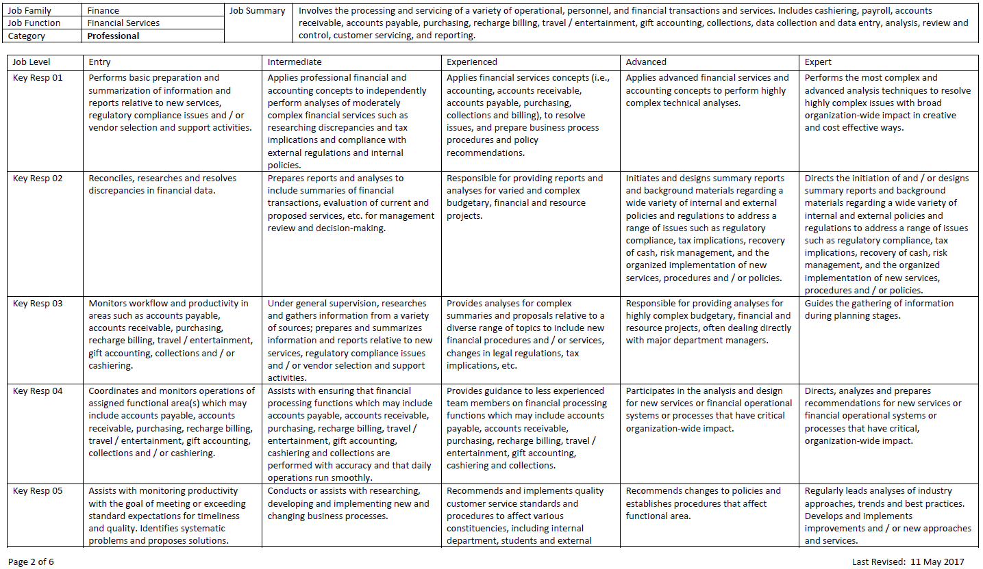
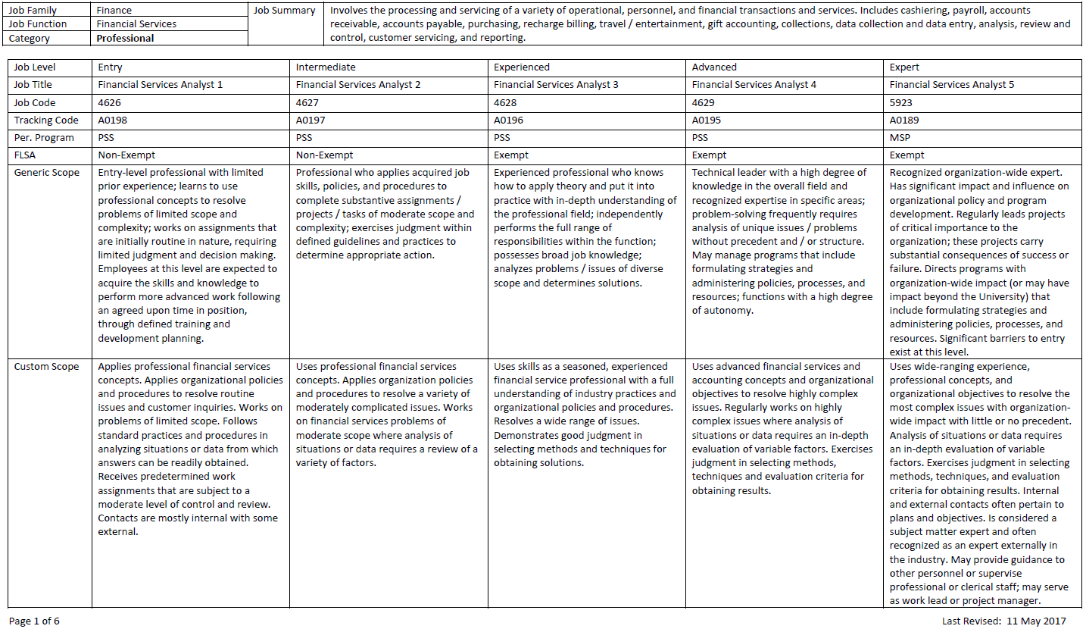
CAREER TRACKS JOB STANDARD –PROFESSIONAL (cont.)
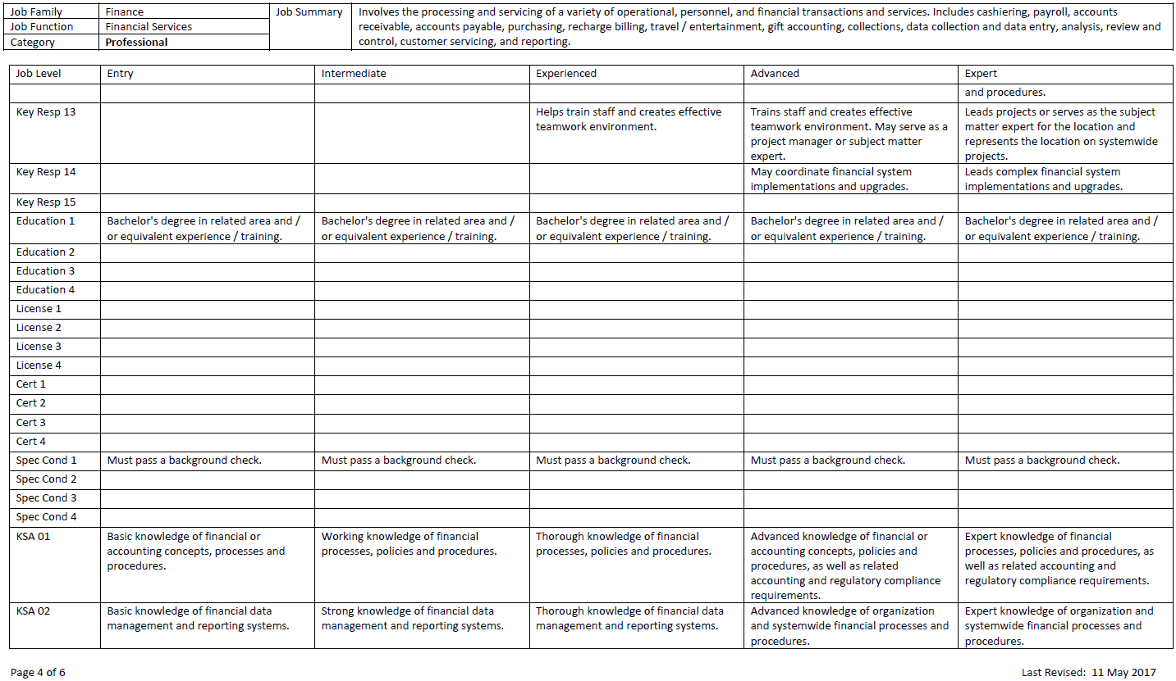

CAREER TRACKS JOB STANDARD –PROFESSIONAL (cont.)
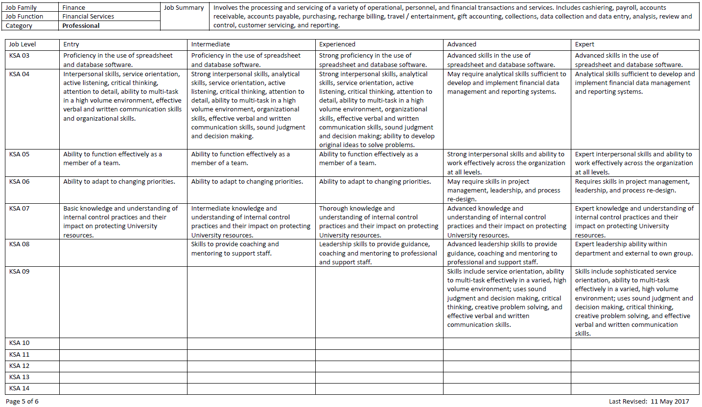
CAREER TRACKS JOB STANDARD –PROFESSIONAL (cont.)
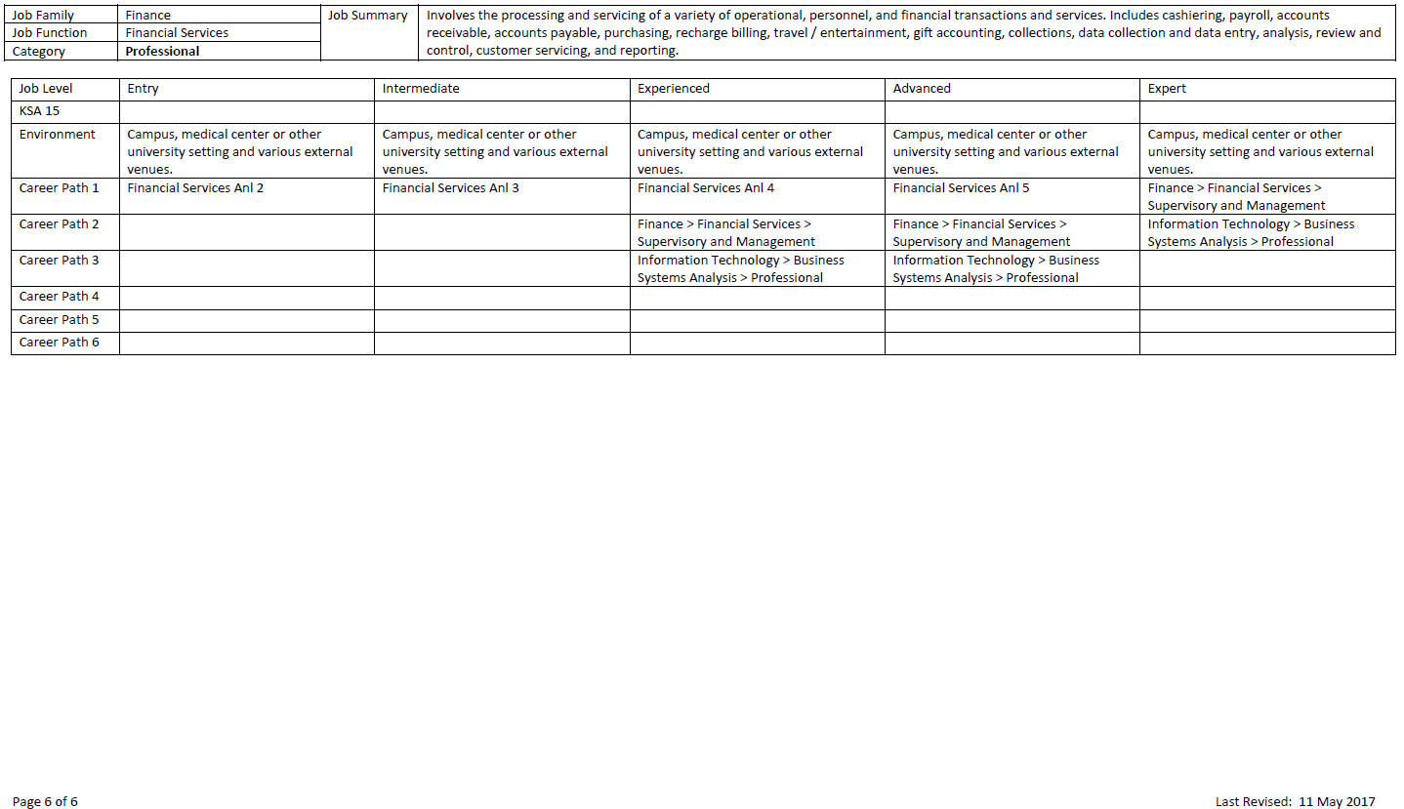
CAREER TRACKS - SUPERVISOR DECISION TREE

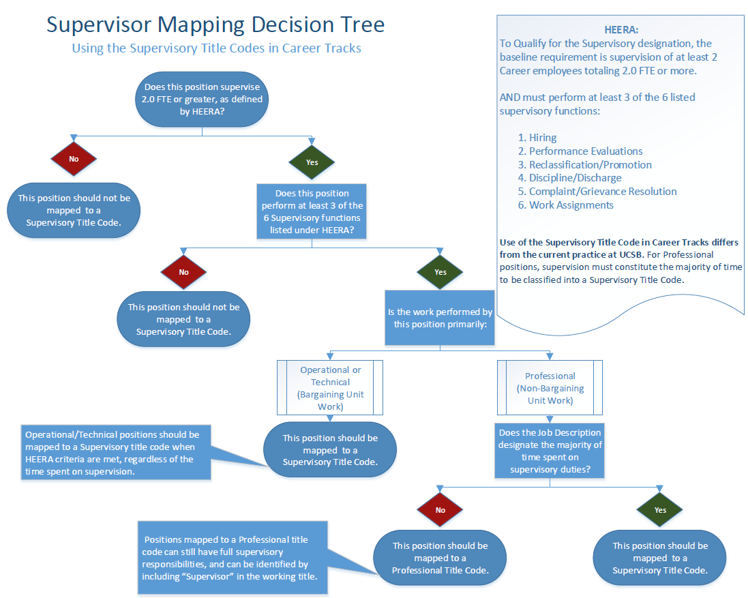
MSP and PSS SALARY GRADE RANGES

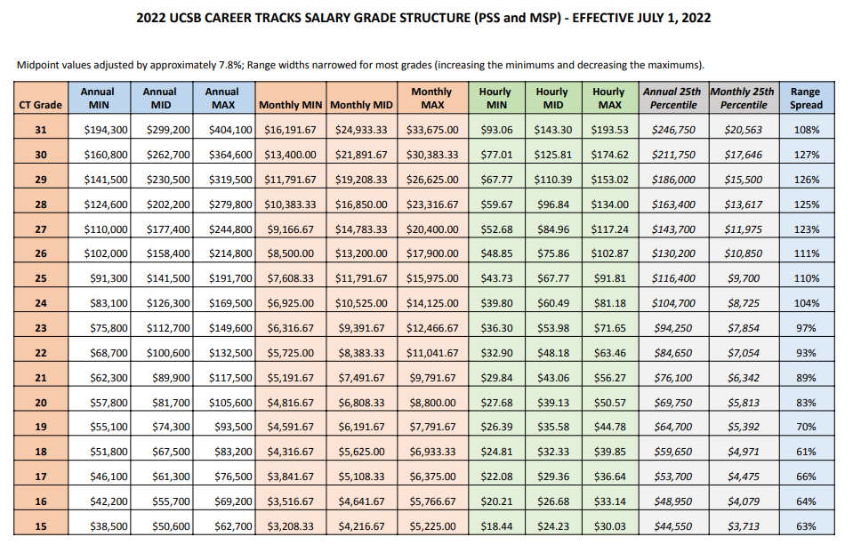MSP and PSS SALARY GRADE RANGES
STUDENT EMPLOYMENT GUIDELINES

A very helpful resource when you will be hiring into / creating a position using a student payroll title is the Student Employment Guidelines. You can find the guidelines within the Talent Acquisition portion of the HR website, in the Hiring section:

Student Employment Guidelines

