Instructions to scan using Google Drive for Android users:
https://support.google.com/drive/answer/3145835?co=GENIE.Platform%3DAndroid&hl=en

**If you don't have a scanner at home there is an App you can get for your iPhone called Tiny Scanner that takes a picture of the document and transforms it into a PDF and saves it as well. **

Instructions to Scan using “Genius Scan” app using iPhone
- In order to scan, click the "+" and scan your documents. The app will detect a sheet of paper and turn orange when it automatically scans it. Select done when finished scanning.
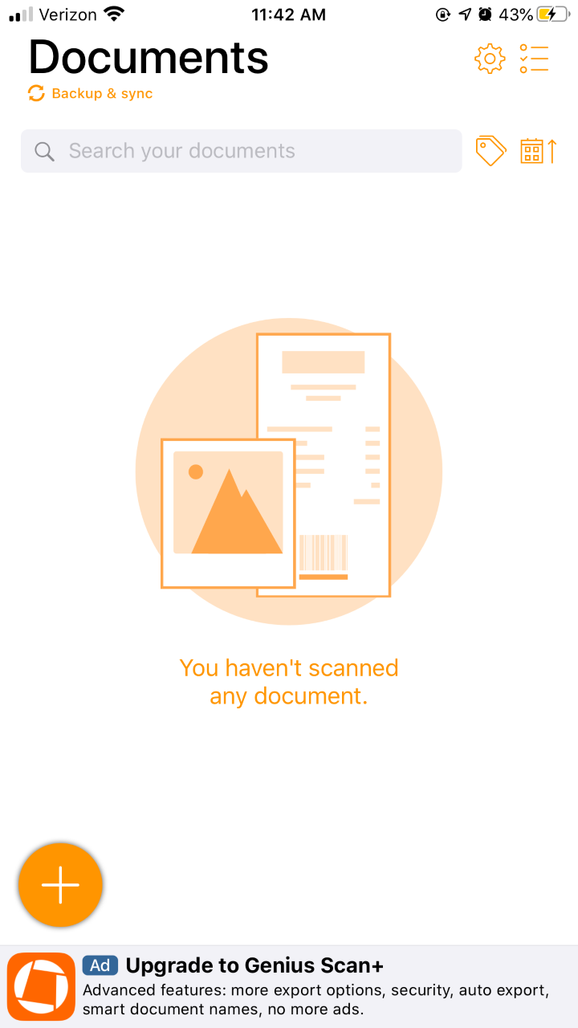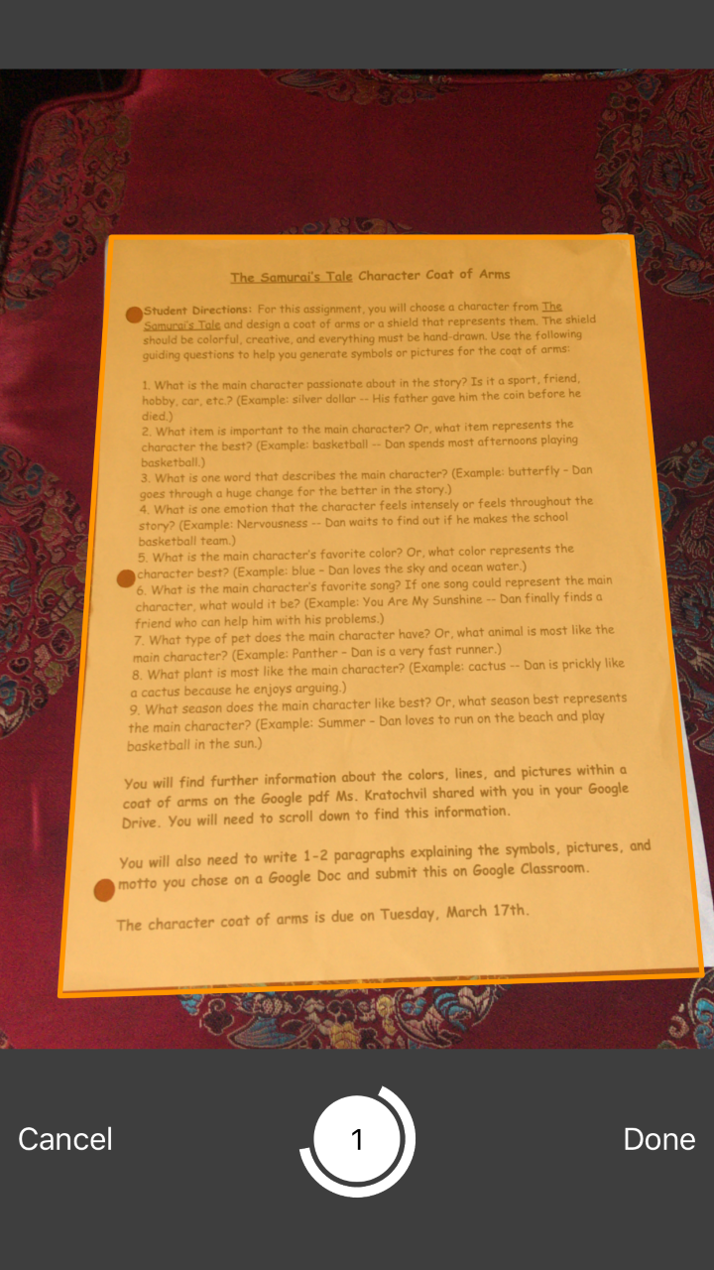

- Press the upload button to email. You need the Apple Mail app in order to email.

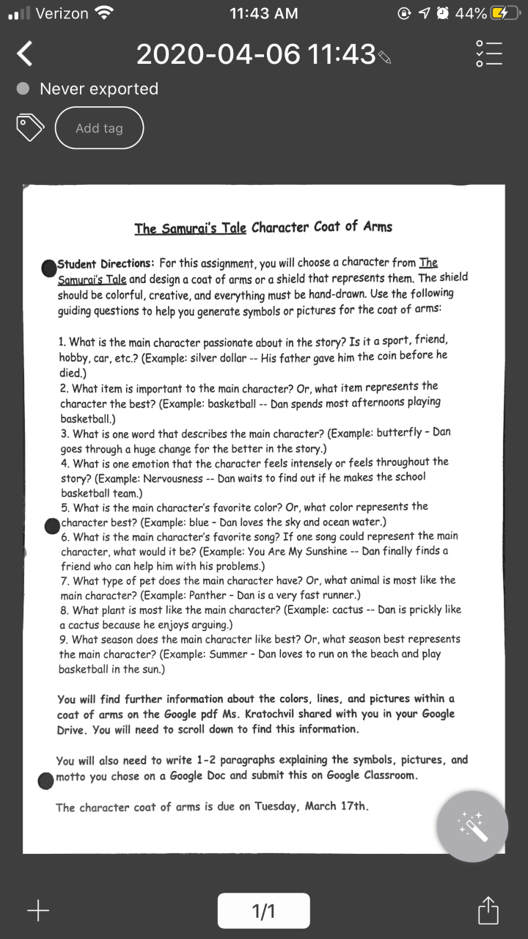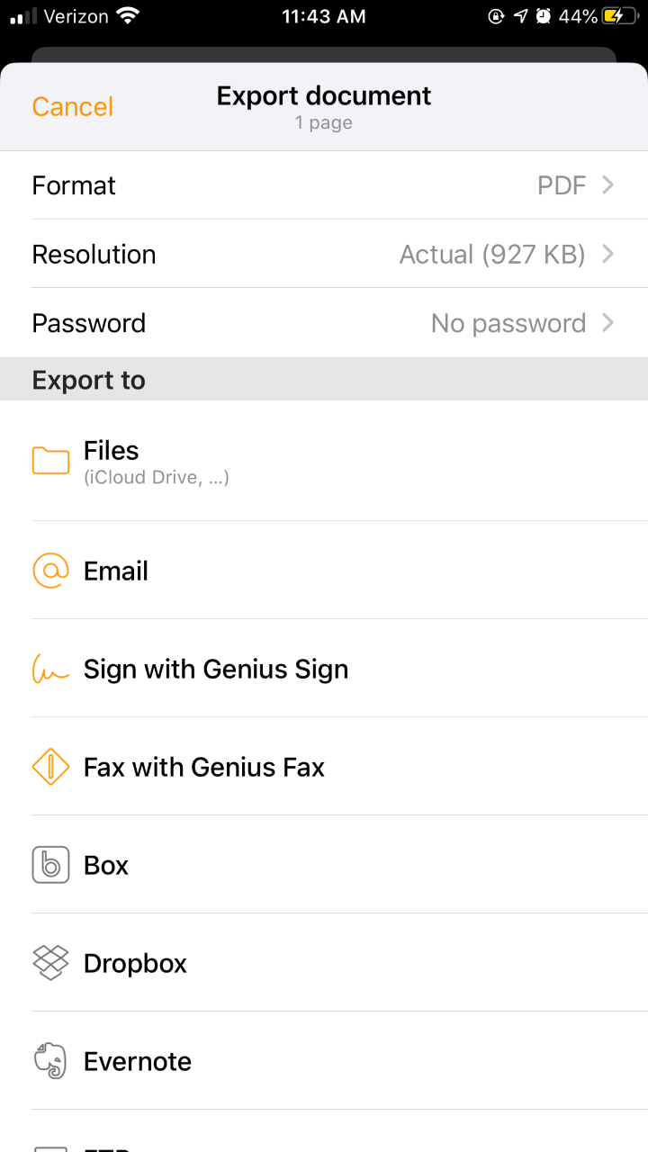
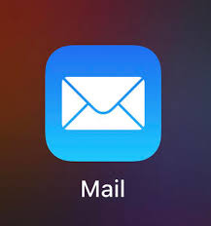 Apple Mail App
