Initiating and processing your retirement online: Steps for members

In accordance with the stay-at-home orders in effect throughout California, RASC representatives have transitioned to limited remote operations. While the transition is going smoothly, we have altered our operations to best serve our members given the circumstances. During this time, however, we will be unable to answer calls as usual, and our ability to process physical mail will be severely limited.

In light of these changes, UCRP members can initiate and process their retirements electronically through UC Retirement At Your Service (UCRAYS, at retirementatyourservice.ucop.edu) by following the steps below. To learn more about how to register, log in and use UCRAYS, visit ucal.us/ucraysfaq.

Please note: If you plan to retire on July 1, it’s recommended that you start this process as early in April as possible.

STEP 1:
Download the Request for Retirement Initiation Packet, available in the resources section of the Preparing for Retirement roadmap on UCnet.

STEP 2:
Complete the request form online, save it as a PDF or Word document, and submit it either:
- Electronically, as a secure message attachment through your UCRAYS account or
- By fax to 1-800-792-5178

STEP 3:
You will receive an acknowledgment email within 5 business days from the date the RASC received the form.

STEP 4:
Within 10 business days from the acknowledgement email, you will receive your Personal Retirement Profile (PRP), including the Election Worksheet and other information (such as how to enroll in Medicare).

STEP 5:
When you have completed the election worksheet with your choices, you will have a new option -- to select Upload Documentation to submit your election worksheet in UCRAYS. Select this option from the menu (as shown below) and follow the step-by-step instructions. As an alternative, you can fax the worksheet to the RASC, but this may delay the processing of your retirement.
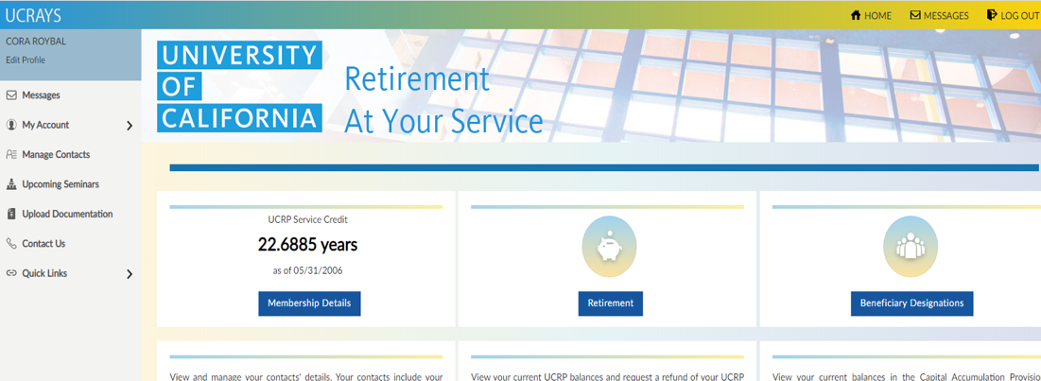

STEP 6:
Within 7-10 business days after the RASC receives your completed election worksheet, you’ll receive your Election Form from the RASC by U.S. mail or as a UCRAYS secure message (if necessary). Sign this form (include your spouse’s signature if applicable), then scan and upload all pages of your signed form and all required documents through the UCRAYS secure upload feature (as shown below). RASC does not need original documents to complete processing.

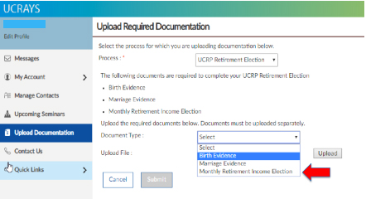

STEP 7:
RASC will review your signed election form and supporting documentation and will reach out to you via UCRAYS secure message within 7-10 business days to confirm that your documentation is complete, or to request additional documentation if needed.

Please note: To receive your first monthly retirement benefit payment by Aug. 1, all documents must be received by May 15, 2020.

STEP 8:
Once you have successfully submitted all required documentation, RASC will finalize the calculation of your benefit and prepare your retirement confirmation letter. This process typically takes from 45-60 days from the date RASC receives all required documentation. Beginning in April, you can track the status of your retirement processing in your UCRAYS account.

Please note: As long as you receive your retirement confirmation letter by July 15, 2020, you will receive your first monthly retirement benefit payment by Aug. 1.

STEP 9:
Enjoy your well-deserved retirement!

Frequently Asked Questions
Q: Will my information be secure through this process?
A: UCRAYS secure messaging and document upload features allow members to send and receive documents and information in a fully secure format. RASC receives documents submitted via fax as secure electronic documents.

Q: How will I know where I am in the retirement process?
A: In April, a new feature will be available in UCRAYS allowing prospective retirees to track the progress of their retirement online. Members with questions and concerns may always contact RASC via UCRAYS secure messaging.

Q: What if I do not have electronic access?
A: Members with urgent issues that cannot be handled through their UCRAYS account will be directed to call a hotline and leave a voice message so a representative can return their call as soon as possible.

Q: I have questions. Can I request a counseling appointment?
A: Members may request a counseling appointment via UCRAYS secure message.

