Extended Absence Report – Data Warehouse

Overview
- Data is pulled directly from the Extended Absence module in UCPath, and includes all approved leave requests entered in UCPath. (Leave details entered in Job Data are contained in a separate report - Coming Soon.)
- The Primary Dept Code and Job Class Code are pulled from Job Data to provide the ability to sort by department and/or population (academic or staff).
- More than one leave entry per employee/leave may exist due to changes in leave status (e.g. Pay status, FMLA Entitlement status, etc.).
  - Compare data points on each line to understand the changes to an employee’s ongoing leave status.
  - In these cases, the Actual Return Date is only entered on the FINAL leave entry.
- If the leave is not eligible under an FMLA/CFRA/PDL entitlement, this field will remain blank.
- Pay date fields only apply to Academic Year Employees paid on a 9/12 schedule and will not appear for any other employee group. (These dates are what are entered in Job Data for AY Employees.)
- Employees on partial paid leaves are included on this report, however details regarding Leave No Salary and reduced schedule percentages are not currently available.

Report Queries
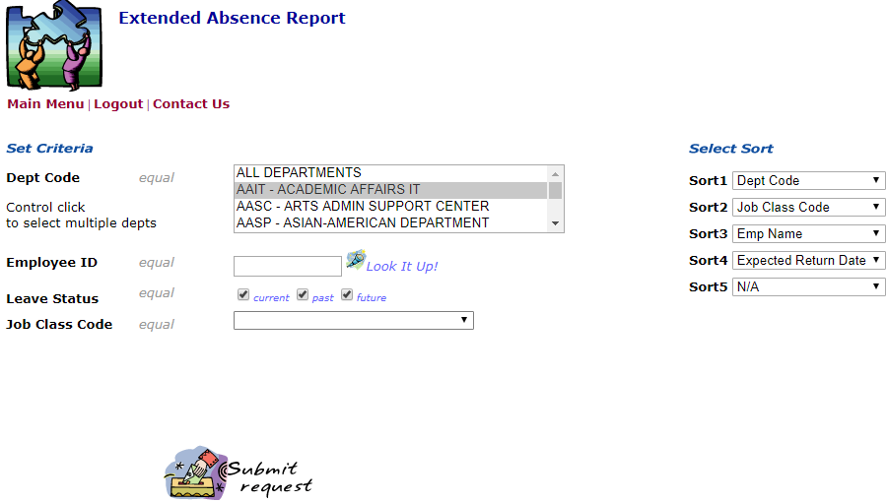
Leave Status allows you to query based on if the leave is current, past or future as of the date the query is run:
- Current Leaves (Leave Begin Date < todays date > Expected Return Date)
- Past Leaves (Expected Return Date < todays date)
- Future Leaves (Leave Begin Date > todays date)
Tips:
- For Academic Year employees, Leave Status option is pulling data based on the SERVICE DATES associated with the leave (not the dates associated with pay that are entered in Job Data).
- Records are pulled into this report based on the employee’s primary Department Code. (If an employee appears to be “missing,” it may be because of this field.)

Report Field Definitions:
Employee Name - Employee Name
Employee ID - UCPath Employee Identification Number
LEAVE DATES:
Last Date Worked - The last day the employee worked prior to beginning a Leave of Absence.
Leave Begin Date - The first day the employee did not work on the existing leave status.
Employees may have more than one leave type in this report as Pay, Entitlement and Leave Types change. (E.g. a Paid Childbearing/PDL leave is followed by an unpaid leave while the employee is receiving disability insurance.)
Expected Return Date - The date the employee is expected to return to work, or the date the leave status changes to a new leave type, pay status or entitlement.
Actual Return Date - The date the employee actually returned to work.
This is only input on the final leave type. (E.g. the employee has a paid childbearing/PDL, immediately followed by an unpaid PDL (paid through disability insurance) - the return date is only input on the unpaid PDL leave entry - when the employee actually returns.
PAY DATES (AY Employees Only):
Academic Year employees (9/12) have different dates associated with their pay and service periods. Pay Start and End dates are what appear in Job Data and differ from the dates the employee is physically out on a leave.
Pay Begin Date (academic only) – The date the employees pay status is placed on leave.
Pay End Date (academic only) – The last date the employees pay status is on leave prior to the actual pay return date.
Pay Return Date (academic only) – The date the employees pay status is returned from leave.
LEAVE DETAIL:
Leave Type – The policy leave type: Medical, Personal, Sabbatical, etc.
FMLA/CFRA/PDLL Entitlement (when applicable) – The legal leave entitlement associated with the leave, when applicable.
Pay Status – The pay status associated with the leave: Paid, Unpaid, Intermittent/Reduced Schedule
Jobs (Ee Record #) Excluded from Leave - The Employee Record # of any jobs that are excluded from the leave. Only applicable If an employee has multiple positions, and the leave is not applied to all job records.
JOB DATA ELEMENTS:
Primary Department Code – The employee’s department under their primary appointment. (Note: Employees with multiple appointments across different departments will only appear on the report for the primary appointment department.
Job Class Code - The employee’s classification (Academic, Staff, Student, etc.) under their primary appointment.

